Pocket money
Maree and her two brothers help around the house.
Maree’s parents set aside $15 per week for pocket money and let the children decide how to divide the $15 between them.
Here are the ways they help around the house and what jobs they finished over one month. A tick means the job was completed every day for that week. A cross indicates that the job was not completed.
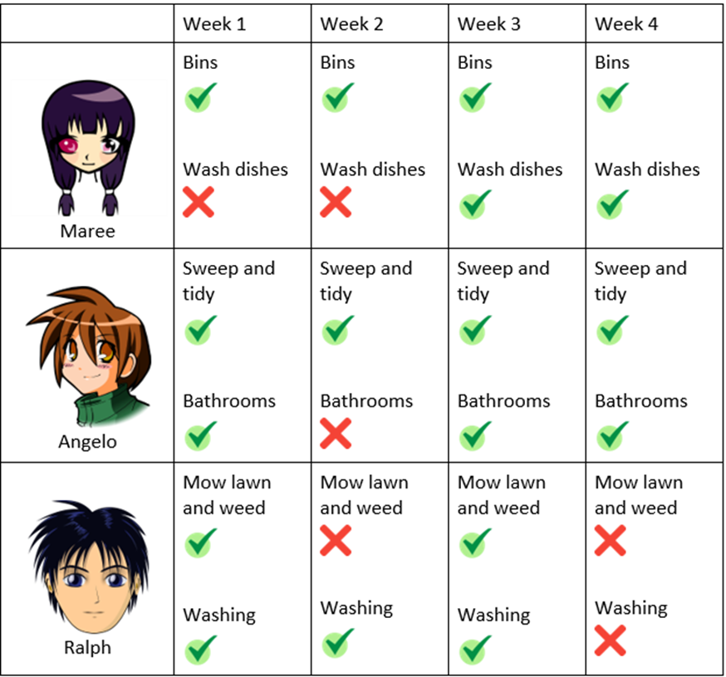
Brainstorm some different ways the pocket money could be divided between the three children each week. Look closely at the jobs completed by each person before deciding how the pocket money should be divided.
Select efficient problem solving strategies to find solutions and communicate all the different possible outcomes showing all your working out.
Calculate the total amount of pocket money each child gets for the 4-week period.
Remember to follow the steps for problem solving:
- Identify | describe
- Plan
- Apply and do (solve)
- Communicate

Pocket money: problem 2

Each child is saving for an item of their choice. If each child continues to perform the same jobs for each 4 week period…
- Estimate the number of weeks required for each child to purchase their item. What is an estimate that is too low? What is an estimate that is too high? Show your working out.
- Show how you could calculate the total amount of time required for each child to purchase their items. Explain your calculations and how you worked it out.
 | Item they are saving for | Amount saved | How many weeks until they can purchase
Maree | New basketball runners  ($125) | $65
Angelo | Skateboard  ($179) | $33
Ralph | Buying a rescue dog  ($325) | $109
Image source: Pixabay and Flaticon

