Activity 1: Exploring the network

Use the Capital Airways route map to answer the questions below. Write your answers in your exercise book or in the spaces provided.

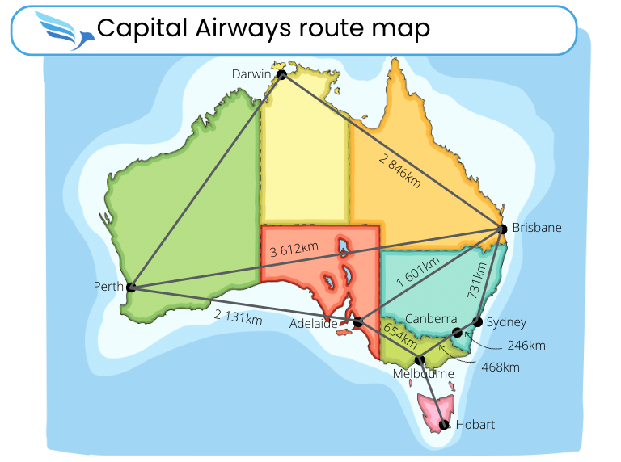

Image: Map of Australia care of KVASVECTOR via Canva.com

1. What is represented by the vertices or nodes in this this network?
2. What is represented by the edges in this this network?
3. Which city has the most flight connections?
4. Which city has the least flight connections?
5. How far is the distance from Darwin to Brisbane?
6. Which cities are 2,131 km apart?
7. The distance between Melbourne and Hobart is 598 km and between Perth and Darwin is 2,648 km. Add these distances to your network diagram.
8. Between which two cities is the distance the greatest and how far is the distance?
9. If you travel from Hobart to Adelaide by the shortest route, how far will you travel?
10. How much further is the distance from Adelaide to Brisbane if you travel via Melbourne rather than travel direct? How many flights do you have to take on the longer route?
11. Draw a simplified network diagram to reflect the capital network. Mark the vertices with the initial letter of each city, for example, ‘A’ for Adelaide.
12. As CEO, you want to tour the country and visit your ground staff in each capital. You can choose any city as your start and end point. Describe a route that visits every city and calculate how far you will travel.
13. Is it possible to plan a route that visits every city only once (without re-visiting a city)? Explain your answer.
14. Is it possible to plan a route that involves travelling every route on the network, without repeating a route? Explain your answer.