Fractions of a flag
Find the fractions of various colours within each of these flags. Simplify fractions where possible.
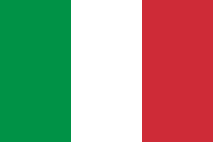 | National flag of Italy  - ________________________  - ________________________  - ________________________
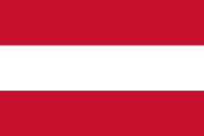 | National flag of Austria  - ________________________  - ________________________  - ________________________
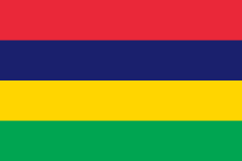 | National flag of Mauritius  - ________________________  - ________________________  - ________________________  - ________________________
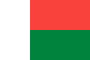 | National flag of Madagascar  - ________________________  - ________________________  - ________________________  ________________________
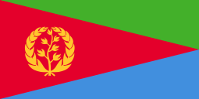 | National flag of Eritrea  - ________________________  - ________________________  - ________________________
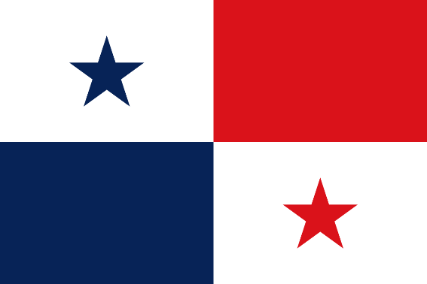 | National flag of Panama  - ________________________  - ________________________  - ________________________  - ________________________
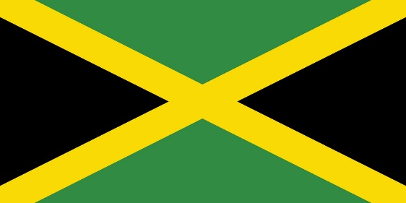 | National flag of Jamaica  - ________________________  - ________________________  - ________________________  - ________________________
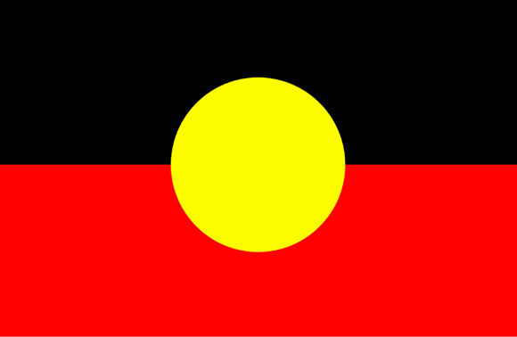 | Australian Aboriginal flag  - ________________________  - ________________________  - ________________________
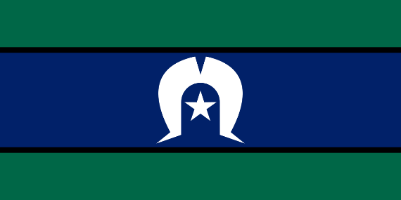 | Torres Strait Islander flag  - ________________________  - ________________________  - ________________________
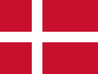 | National flag of Denmark  - ________________________  - ________________________  - ________________________  - ________________________
*Note 1: All country flags are civil flags where relevant, and are current as at 22nd October 2023*
*Note 2: For ease of discussion/use, you may wish to concentrate on the primary elements of each flag*

