Osprey ranking threats
Year level  Strand(s)  Lesson length  CD Code: | - Year 5, Year 6  - Statistics  - 60 mins  - AC9M5ST01  - AC9M6ST01
Lesson summary | In this lesson, students acquire data related to key threats to the survival of osprey. Students work in small groups to rank a list of key threats and collate the data in a class spreadsheet. They sort the data to identify the overall class ranking of threats. Students create a pie chart of the threats commonly ranked as most important (ranked 1).  This lesson is the fifth in a series of six lessons that connect the cross-curriculum priority of Sustainability, Statistics and the Science learning area: Science as a human endeavour. AC9S5H01, AC9S6H01 and AC9S5H02, AC9S6H02.  This lesson was developed in collaboration with Conservation Without Borders. Data and information provided by Tweed Valley Osprey Project.
Learning intention | - We are learning about ways to represent and report on real scientific data.  - We will use the research tasks to develop our data skills including using a spreadsheet and creating charts.
Success criteria | By the end of this lesson, students can:  - rank a set of data  - sort data using a filter  - visually represent data as a pie chart.
Why are we learning about this? | The work done by research teams helps us to learn more about the natural world. Using the context of contributing to a research team gathering data, we can identify patterns, analyse trends, and observe changes over time. Exploring basic technologies, such as GPS tracking used by scientists, enhances our understanding of data collection and analysis. Additionally, mastering the creation and interpretation of data displays is a crucial skill, as it allows us to communicate information effectively through visual means.
Prerequisite student knowledge and language | Prior to this lesson, it is assumed that students have knowledge of:  - interpreting information in a table  - ranking data  - using a pie chart to represent data.  It is also assumed students are familiar with terms such as:  - threats  - percentage.
Resources | - Lesson plan (Word)  - Teacher’s slides (PowerPoint)  - Ranking threats to osprey-sheet (Word)  - Class ranking spreadsheet (Excel)  - Sacha Dench profile poster  - Access to computer/tablet and spreadsheeting software such as Excel (MS) or Numbers (iOS)
Curriculum information
Achievement standard | By the end of Year 5, students interpret and compare data sets for ordinal and nominal categorical, discrete and continuous numerical variables using comparative displays or visualisations and digital tools. They identify the mode and interpret the shape of distributions of data in context. They compare distributions of discrete and continuous numerical and ordinal categorical data sets as part of their statistical investigations, using digital tools.  By the end of year 6, students compare distributions of discrete and continuous numerical and ordinal categorical data sets as part of their statistical investigations, using digital tools.
Content description(s) | Students acquire, validate and represent data for nominal and ordinal categorical and discrete numerical variables, to address a question of interest or purpose using software including spreadsheets; discuss and report on data distributions in terms of highest frequency (mode) and shape, in the context of the data. AC9M5ST01  Students interpret and compare data sets for ordinal and nominal categorical, discrete and continuous numerical variables using comparative displays or visualisations and digital tools; compare distributions in terms of mode, range and shape. AC9M6ST01
General capabilities  Cross-curriculum priority | General capabilities  Numeracy  - Interpreting and representing data (Level 4)  Digital literacy  - Investigating: Interpret data (Level 4)  - Investigating: Acquire and collate data (Level 4)  - Creating and exchanging: Create, communicate and collaborate (Level 4)  Cross-curriculum priorities  Sustainability  - Futures (SF1)
Areas of challenge | Some students may:  - have difficulty ranking a set of data  - have difficulty transferring data in a table to a visual representation such as a pie chart  - have limited familiarity with working with data using a spreadsheet  - require support to interpret different charts and to choose the most suitable chart to represent a data set.
Strategies | - Mathematics investigation  - Collaborative learning  - Explicit teaching
Lesson structure
Learning hook  5 mins | Download the teacher’s slides to accompany your teaching.  Use the quick quiz (slide 2) to introduce how conservation efforts are increasing the number of osprey.  - Explain that today we will be exploring how to rank and prioritise a list of threats to the osprey based on their importance, urgency or impact (slide 3).  - We will use a shared spreadsheet to collate group data to get an overall class ranking.
Explore  50 mins | Introduction (15mins)  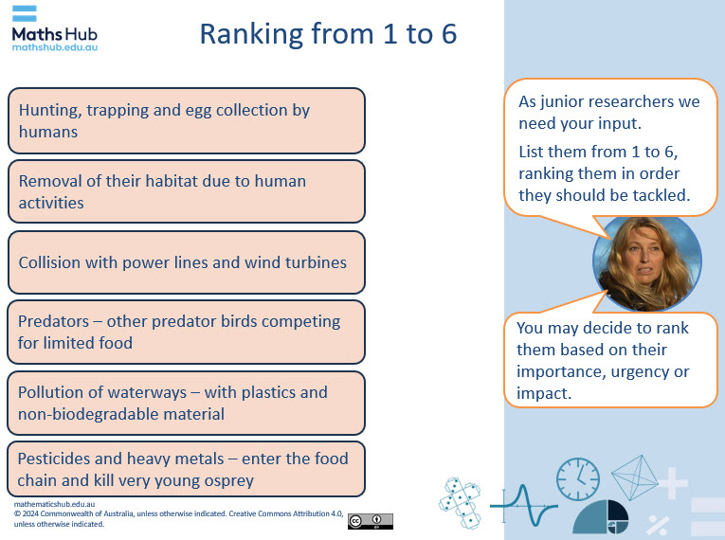  Slide 5  - List the six largest threats for the migrating osprey (slide 4).  - Explain that rankings provide a concise and effective way to communicate information. They can be easily understood and shared among different stakeholders.  - Organise students into small groups and provide each group with the Ranking threats to osprey sheet to discuss and record their group’s agreed ranking. The ranking of each threat can be based on its importance, urgency, or impact. To fully engage in ranking the threats students could have discussed these already in a science focused lesson.  Class collaborative activity (10 min)  - Introduce the task of collating group rankings into an overall class ranking (slides 6–8).  - Display the Class ranking spreadsheet (Excel). Provide each group with the spreadsheet so they can input their data.  - Assign each group a number that corresponds to a column on the spreadsheet, for example Group 1. Have a representative from each group to add their data to their group’s column in the shared spreadsheet.  - Demonstrate how to sort and filter the data selecting the total (column L) smallest to largest. Explain how this now ranks the questions in order of importance as suggested by the class.  - Explain that by creating a class table of information, students can use this data to see the collective opinions of the class and gain insights into the overall ranking of threats to osprey.  Practical task (25 min)  - Explain that students will use the compiled class data to identify the threats commonly ranked most important by totalling the threats ranked 1 in a new table.  - Students visually represent these threats using a chart. They use a laptop or tablet to access and save the data in a table on their own device and create a column graph or a pie chart to visualise the information.  - Students can refer to the tab ‘Threats ranked 1’ which provides a table and a sample pie chart to use.  - Once the graph is created, discuss the results with the class. Ask students to explain their group rankings and discuss any patterns or trends that emerge from the class collated data.  Differentiation (enable)  - How can you rank data? How does sorting data help with data interpretation?  Differentiation (extend)  - How does a pie chart use percentage? Is there any benefit in using a pie chart over a column graph? Explain your answer.
Summary and reflection  5 mins | - Encourage students to reflect on the process and discuss how their individual rankings compare to the class collated data. This can help them understand different perspectives and the importance of collaborative decision-making.  - Discuss the statement, ‘Ranking helps focus resources on the most important things first, making resource allocation more efficient.’
Assessment | Have students save the digital versions of their column graph or pie chart to record and view their progress in use of spreadsheeting software such as Excel (MS) or Numbers (iOS)  Class collaboration  - How well does each group collaborate and use a shared spreadsheet to share class data?  - Can they successfully input their group data into a shared spreadsheet?  - Can they interpret the table of data?  Individual task  - Are students able to use the class data to create their own table of data related to the threats ranked 1?  - Can students represent the data visually using a chart?  - Can students correctly interpret their charts?  Discuss ranking as a survey technique.  - Can they describe the process of ranking data?  - Can they describe benefits and issues related to ranking data?

