Log graph: COVID-19 cases

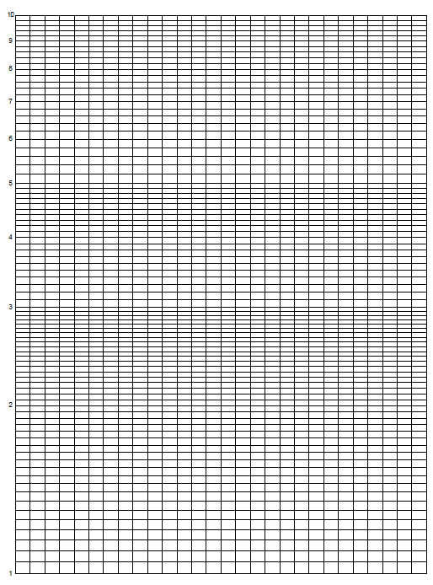

Write a few sentences explaining what your data shows.

|  |
| --- |
|  |
|  |
|  |
|  |
|  |
|  |

## Data file

New COVID-19 cases February 2020 to August 2022 by month

|  |  |  |  |  |  |  |  |  |  |
| --- | --- | --- | --- | --- | --- | --- | --- | --- | --- |
|  | NSW | Vic | Qld | SA | WA | Tas | NT | ACT | Total |
| Feb-20 | – | 4 | 7 | 3 | 2 | – | – | – | 16 |
| Mar-20 | 2028 | 910 | 734 | 334 | 362 | 69 | 19 | 80 | 4536 |
| Apr-20 | 1173 | 444 | 290 | 101 | 187 | 154 | 8 | 26 | 2383 |
| May-20 | 79 | 288 | 25 | 2 | 33 | 5 | 2 | 1 | 435 |
| Jun-20 | 94 | 510 | 9 | 3 | 15 | – | – | 1 | 632 |
| Jul-20 | 378 | 8418 | 16 | 7 | 41 | 1 | 3 | 5 | 8869 |
| Aug-20 | 294 | 8503 | 39 | 13 | 15 | 1 | 1 | – | 1366 |
| Sep-20 | 174 | 1089 | 35 | 5 | 29 | – | – | – | 1332 |
| Oct-20 | 197 | 178 | 14 | 33 | 84 | – | 5 | 1 | 512 |
| Nov-20 | 156 | (2) | 31 | 61 | 50 | – | 14 | 3 | 313 |
| Dec-20 | 346 | 23 | 51 | 14 | 43 | 4 | 22 | 1 | 504 |
| Jan-21 | 181 | 80 | 57 | 21 | 42 | – | 24 | – | 406 |
| Feb-21 | 73 | 33 | 19 | 16 | 10 | – | 7 | – | 158 |
| Mar-21 | 115 | 3 | 138 | 42 | 29 | – | 3 | 5 | 335 |
| Apr-21 | 185 | 34 | 92 | 69 | 57 | – | 58 | 1 | 496 |
| May-21 | 110 | 80 | 59 | 30 | 19 |  | 7 |  | 305 |
| Jun-21 | 239 | 114 | 78 | 53 | 10 |  | 11 |  | 505 |
| Jul-21 | 3088 | 232 | 104 | 52 | 29 |  | 15 |  | 3520 |
| Aug-21 | 18,095 | 1127 | 179 | 12 | 29 | 1 | 3 | 274 | 19,720 |
| Sep-21 | 35,344 | 15,262 | 56 | 30 | 10 | – | 9 | 561 | 51,272 |
| Oct-21 | 12,925 | 51,491 | 54 | 17 | 16 | 2 | 14 | 816 | 65,335 |
| Nov-21 | 6396 | 32,903 | 38 | 14 | 9 | 2 | 63 | 355 | 39,780 |
| Dec-21 | 105,830 | 54,807 | 1,1736 | 101,146 | 37 | 546 | 286 | 1880 | 185,268 |
| Jan-22 | 705,728 | 645,612 | 289,124 | 94,304 | 369 | 28,716 | 15,184 | 23,537 | 1,802,574 |
| Feb-22 | 237,891 | 218,614 | 78,752 | 42,489 | 7837 | 15,657 | 24,510 | 21,994 | 64,7744 |
| Mar-22 | 506,069 | 241,863 | 376,321 | 109,696 | 164,863 | 44,326 | 9652 | 28,173 | 1,480,963 |
| Apr-22 | 460,428 | 278,792 | 228,379 | 148,908 | 212,884 | 46,397 | 13,369 | 26,411 | 1,415,568 |
| May-22 | 483,898 | 335,080 | 188,188 | 108,874 | 348,723 | 28,538 | 8578 | 27,813 | 1,529,692 |
| Jun-22 | 224,867 | 213,814 | 118,082 | 77,209 | 170,365 | 23,549 | 6540 | 25,740 | 860,166 |
| Jul-22 | 380,752 | 310,754 | 218,793 | 115,968 | 158,645 | 43,272 | 12,599 | 33,200 | 1,273,983 |
| Aug-22 | 246,796 | 143,277 | 94,840 | 45,059 | 64,718 | 14,311 | 4759 | 11,665 | 624,925 |