How much water does our class use?
Year level  Strand(s)  Lesson length  CD Code: | - 6  - Number  - 50–60 mins  - AC9M6N09
Lesson summary | In this lesson, students gain awareness about water usage associated with common activities around the home. They use a modelling approach to work towards determining an approximate answer to the question ‘How much water does our class use at home?’ They enhance their proficiency in reading and saying numerals beyond 1000 out loud.  This lesson is the first of 5 lessons that connect the cross-curriculum priority of Sustainability with Number, Measurement and Statistics. It can also complement the science content description AC9S6U04.
Learning intention | - We are learning about identifying important information and devising a plan to solve a practical problem in a real-world context.  - We model a real-world context using approximations to estimate outcomes.  - We read and interpret a household water bill.  (Also available on slide 2 of the teacher’s slides)
Success criteria | By the end of this lesson, students can:  - identify important information to solve a practical problem in a real-world context  - devise a plan to solve a practical problem in a real-world context  - model a real-world context using approximations to estimate outcomes  - read and interpret a household water bill.
Why are we learning about this? | Modelling a real-life context helps us to better understand a problem and make informed decisions.  Understanding how much water we use in common household activities helps us become more aware of our consumption, which is critical in a world where water is a finite (limited) resource.  Helping us see the connection between our everyday actions and the larger environmental impact is important for sustainable use of resources.  (Also available on slide 3 of the teacher’s slides)
Prerequisite student knowledge and language | Prerequisite student knowledge and language  - Read, write and interpret numbers up to 1000  - Read and interpret a column graph  - Understand that an average is a single number that represents a set of numbers  - Know the number of days in a week, month and year  Language  - assumption  - average  - estimation  - household  - litres  - per person
Resources | - Teacher’s slides (PowerPoint)  - Water bill handout (Word)
Curriculum information
Achievement standard | Students use estimation to find approximate solutions to problems involving rational numbers and percentages. They use mathematical modelling to solve financial and other practical problems involving percentages and rational numbers, formulating and solving the problem, and justifying choices.
Content description(s) | Use mathematical modelling to solve practical problems involving rational numbers and percentages, including in financial contexts; formulate the problems, choosing operations and using efficient mental and written calculation strategies, and using digital tools where appropriate; interpret and communicate solutions in terms of the situation, justifying the choices made. AC9M6N09
General capabilities  Cross-curriculum priority | General capabilities  - Number and place value (Level 6)  Cross-curriculum priorities  Sustainability  - Futures (SF2)
Areas of challenge | Some students may:  - require support read and speak numbers beyond 1000  - find it challenging identifying and interpreting important information from a water bill  - require support to make assumptions to approximate values.
Strategies | - Mathematics investigation  - Classroom talks  - Questioning  - Structuring lessons
Lesson structure
Learning hook  10 mins | Project slide 4 from the teacher’s slides.  Water usage in the home  Which one of the following do you think uses the most water in the home?  - Dishwasher  - Washing machine  - Toilet  - Shower  - Outdoor  - Tap and bath  Use slide 5 to support students to estimate approximate percentages for water use in the home based on the six categories.  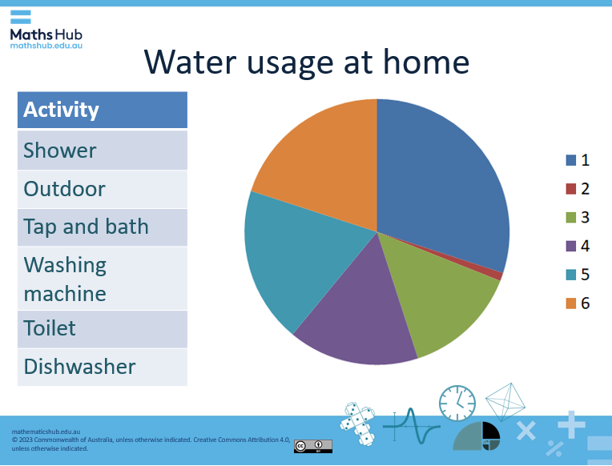  Slide 5  Ask students to:  Estimate the percentage of each segment of the pie chart.  Match the segment number and colour to the water usage in the home.  - Using the slides 6 and 7 display the actual results from data from Melbourne Water. Students compare their responses with the results.  - What uses the most water in the home?  - How good were you at estimating what uses the most water in the home?  - Is there anything that surprised you about the difference in the amount of water each of the activities uses?  - Slide 7 of the teacher’s slides shows a table with the percentage of water used at home for each activity, ordered from highest to lowest usage. Use this to further extend and support the discussion.
Explore  35 mins | Introduction (10 mins)  - Slide 8 of the teacher’s slides displays the problem to solve in this lesson.  How much water does our class use at home?  - Ask students to think about how they could go about answering this question and to write down any ideas or questions they have. Have them do this individually to start with, to give them time to process and consider the question, and then hare their ideas with others in groups of 2–4.  - Anticipated student questions:  - How much water does a person use at home per day?  Prompt them to consider where they could find this data, for example, in a home water bill.  - Over what timeframe – day, week, month or year?  Ask them what they think a good starting timeframe is. They may realise that once you have the value for a day, others are easier to calculate.  - Does everyone use the same amount of water a day?  This question provides a good opportunity to reinforce the concept of ‘average’ and that when making an estimate it is common to work with average values or approximations.  - What units is water measured in?  Ask them to consider the units of measure of everyday items that hold liquid, for example, milk carton, drink bottle, can of soft drink. What units of measure do they use? (Units of measure for liquids will be explored in more detail in another lesson, for this lesson, working in litres is enough.)  - Project slide 9 of the teacher’s slides, showing the water bill.  Explore the water bill together, to ensure students understand the information on the bill.  - How many litres of water did this household use per day on average?  - Do they use this much water per day on average all year?  - How many people are in this household?  - Check to see if students have any additional clarifying questions before solving the problem.  - Encourage students to plan their approach to solving the problem individually and then follow their plan, seeking help as required. You could make calculators available to ensure those who find some of the calculations challenging can still engage in solving the problem. You could also use spreadsheet software to calculate litres used per day/week/month/year.  - Distribute the Water bill handout. (The bill for a 2-person household is also available on slide 7 of the teacher’s slides.)  Two water bills have been included, as some students may wish to take additional information into account when establishing their estimate for the average water usage per day per person.  The dashed line on the water bill graph indicates the 440 litre mark (Step 1). Water becomes more expensive above Step 1.  - Questions and prompts:  - How much water did each person use per day in the 2-person household? How does this compare to the 3-person household?  - Does the average daily water usage per person change over a year? Why might that be?  - What assumptions do you need to make to solve the question: How much water does our class use at home?  - Once students have an estimate for how much water the class uses a day, have them draw up and complete the following table.  Duration Amount of water used at home by the class, in litres  Day  Week  Month  Year  Differentiation (support) – use only the 2-person water bill  - How many litres of water did the 2-person household use at home per day? How can we use this value to calculate how much water each person in that house uses at home a day?  - What else would we need to know to calculate how much water our class uses per day?  - If there were 10 people in our class, how much water would they all use at home in one day?  - How many days are there in a week/month/year?  Differentiate (extend)  - How much water would the whole school use at home per day?  - Approximately how many litres of water does the class use for showering each day?  - What is the approximate average daily water usage per person at home over a year in the 3-person household?  Compare the water usage graphs for the 2- and 3-person households. How are they similar and how are they different?
Summary and reflection  10 mins | Ask students to reflect on and summarise the key learnings from the lesson. They could write their ideas in different ways such as in their workbook, sketching a mind map on paper or using Canva, or recording themselves explaining their findings to someone else.  Depending on the students, consider providing some guiding questions:  - What did you find most surprising about water in the home today?  - What units of measure are used when we’re looking at water usage at home?  - What steps did you work through to estimate an answer to today’s question?  - Why might the amount of water we use a day matter?  (Also available on slide 8 of the teacher’s slides.)
Assessment  5 mins | - Exit ticket:  1. Write down an estimate of a person’s very high daily water use at home (uses a lot of water).  2. Write down an estimate of a person’s very low daily water use at home (uses very little water).  Expected answers: 1. values above 200 litres per day 2. values below 140 litres per day

