Locating points on a Cartesian plane
The location of points on a Cartesian plane is given using paired coordinates (x) and (y).
The x coordinate in the pair is always first, y is next.
The osprey is located at (8, 10).
- Locate these objects using their coordinates.
- The nest
- Electrical tower
- Wind turbines
- The birdwatcher (binoculars)
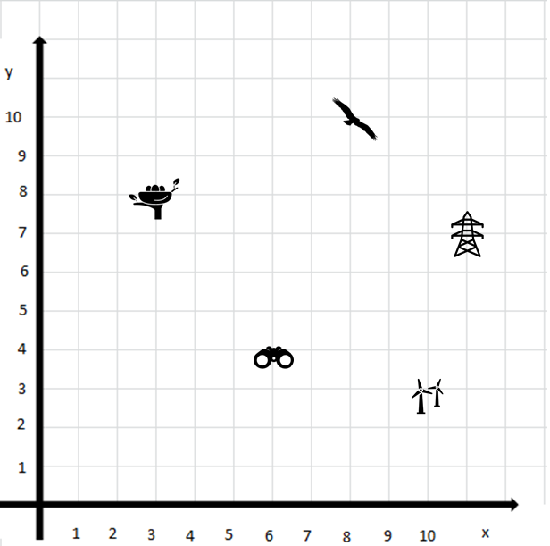

- Plot points for the location of these objects on the Cartesian plane:
- Osprey (3, 4)
- Electrical tower (8, 9)
- Wind turbine (10, 3)
- Nest (10, 6)
- Birdwatchers (6, 4)
- Plot a pathway for the osprey to safely reach the nest. Avoid going near the electrical tower or wind turbine.
