Teacher background information

Instructive games and toys

Connecting First Nations Australians’ histories and cultures and the content descriptions
Games and toys have long been used by First Nations peoples as instructional devices and models for educational, social and cultural learning. They play an important role in the acquisition of knowledge, understanding and skills that will be required later in life for children and young people. These content descriptions provide students with the opportunity to create and follow algorithms and demonstrate how to provide instructions through learning about and playing an Australian First Nations instructive game.
By learning through Aboriginal and Torres Strait Islander instructive games and toys, students are given the opportunity to develop knowledge and understanding that helps to make sense of their world. Students can also develop pride and respect for the cultural heritage of such games both from the past and the present and how they are an important part of Australia’s cultural, social and historical record, and an important aspect of the cultural heritage and cultural expressions of Australia (Edwards, 2012, p. 20).

Detail
Instructive toys used in games are objects of play, mostly designed for children, that stimulate learning by promoting the development of a specific skill or providing play experiences to learn about a particular subject (ACARA, 2019, p. 31). For many thousands of years, instructive toys and games have been an essential means to develop the skills that children will need in adult life (ACARA, 2019, p. 33).
Instructive toys and games are both educational and social in their usage for First Nations Australians. Many teach important concepts, thinking, understandings and skills related to Country/Place, peoples and culture, and prepare children for their place and role in family, community and beyond. Traditional –and contemporary – games of Aboriginal and Torres Strait Islander peoples can provide innovative and ‘fun’ ways to learn.
Traditionally, instructive games were generally associated with the process of learning basic survival skills such as:
- procuring food
- making or gathering material culture/technologies, hunting and fishing implements
- imitating adults in whatever they were doing. (Edwards, 2012)

They were part of day-to-day living and were often a seamless and inseparable cultural expression. ‘There were some traditional games undertaken at particular times of the day or seasons or as part of special rituals and ceremonies (such as initiation) or at special large social gatherings’ (Edwards, 2012, pp 8-9). These games also were symbolic of the season; many of the games were specific to the season, for example, summer or winter.
As well as developing fine and gross motor skills, these traditional games were also associated with other abilities such as memorising, sequencing, visual literacy/numeracy, and visuo-spatial awareness and language Edwards, 2012, p.12). As part of their educative and social roles, adults would make – or help children make – toy or scaled-down versions of adult tools such as spears and digging sticks (involving the skill of scale and translation). They would also make models or miniature representations of objects such as dolls (babies), toy canoes or dilly bags. Other examples of games include:
- word play and games (for example, counting and chanting)
- vocabulary games (for example, learning words for objects; twirling a lighted stick and saying names of different types of fish)
- general play and playful learning, which contributes toward linguistic and visual literacy development and spatial awareness (including learning through movement)
- developing skills in tracking, homing, navigating and finding water, all of which require ready ability to notice the possibilities and vagaries of terrain, wind, waves and weather (survival learning and practice through play associated with these skills allowed for important information to be learned).
The role of play and games (in the past, present and future of a society) is recognised as an important contributor in the creation, development and maintenance of knowledge, value and belief [and knowledge] systems. Through games, children learn something about the cultural values of the group and life skills (Edwards, 2017).

Culture
The Aboriginal and Torres Strait Islander Histories and Cultures cross-curriculum priority in the Australian Curriculum (Version 9.0) highlights Culture as one of the three organising ideas (along with the organising ideas of ‘Country/Place’ and ‘People’). The key organising idea of Culture:
- examines the cultural diversity of the First Peoples of Australia and the First Nations Peoples of the Torres Strait, including their unique ways of being, knowing, thinking and doing
- recognises Australia’s First Peoples as belonging to the world’s oldest continuous cultures and acknowledges the many historic and enduring impacts on the cultures of First Nations Australians
- clarifies that the cultures of First Nations Australians are not static and have internationally enshrined rights that ensure they can be maintained, controlled, protected and developed.
The Australian Curriculum (V. 9.0) organising ideas for Culture:

A_TSIC1: First Nations Australian societies are diverse and have distinct cultural expressions such as language, customs and beliefs. As First Nations Peoples of Australia, they have the right to maintain, control, protect and develop their cultural expressions, while also maintaining the right to control, protect and develop culture as Indigenous Cultural and Intellectual Property.

A_TSIC2: First Nations Australians’ ways of life reflect unique ways of being, knowing, thinking and doing.

A_TSIC3: The First Peoples of Australia (Aboriginal Peoples) belong to the world’s oldest continuous cultures. First Nations Australians demonstrate resilience in the maintenance, practice and revitalisation of culture despite the many historic and enduring impacts of colonisation, and continue to celebrate and share the past, present and future manifestations of their cultures.

Kolap
There are many games associated with traditional hunting techniques (Edwards, 2012) that involve throwing, such as the throwing of scaled-down spears or boomerangs or other objects of various sizes and shapes. Playing throwing games teaches concepts such as luck and develops skills such as accuracy (target practice) and distance.
Kolap is a game of throwing skill. Variations of the game are played all around Australia. The name ‘kolap’ refers to the kolap beans that were used in the Torres Strait Islands to play the game.
Kolap is a group game of social interaction whereby two players form a team and sit diagonally opposite each other, about 5 to 7 metres apart. Each group has a small mat in front of them, and players have four kolap beans that they attempt to throw and land on the mat opposite them. Players take turns within the team to try to reach a combined team total of 20.
Further details about the game (from the Australian Sports Commission) can be found here: https://www.sportaus.gov.au/__data/assets/pdf_file/0005/704858/kolap.pdf

Connecting with communities
Learning opportunities can be further contextualised and deepened through a process of connecting with local Aboriginal and Torres Strait Islander communities, knowledges, cultures and language/s. Acknowledging, consulting and collaborating with communities provides opportunities for two-way learning that is essential for creating, implementing and evaluating resources, teaching and learning strategies, and curriculum content. All students benefit from connection with community.
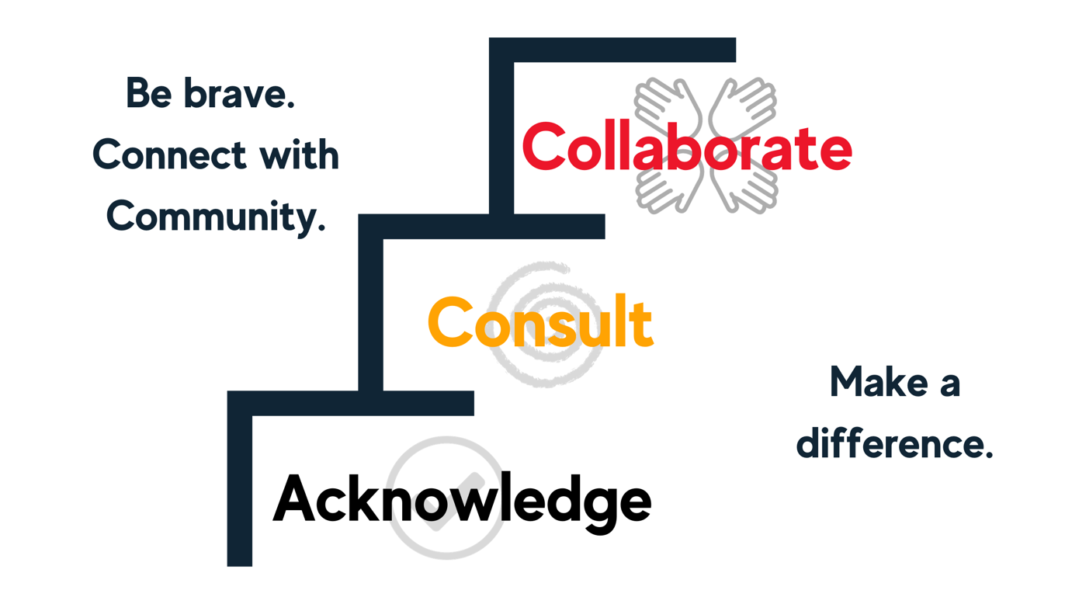
Source: Maths in Schools and ATSIMA

References and further reading
ACARA. (2019). Australian Curriculum: Science – Aboriginal and Torres Strait Islander Histories and Cultures cross-curriculum priority: Content elaborations and teacher background information for Foundation to Year 6. ACARA. https://www.australiancurriculum.edu.au/media/5653/ccp-tbi-f-6-ver5-online.pdf
Edwards, K. (2012). A typology of the traditional games of Australian Aboriginal and Torres Strait Islander peoples. Ram Skulls Press.
Haagen, C. (1994). Bush toys: Aboriginal children at play. Aboriginal Studies Press.
Queensland Sport and Recreation. (2018). Traditional Indigenous Games: Kolap [Video file]. Retrieved from https://www.youtube.com/watch?v=40A1qRnLhK4

