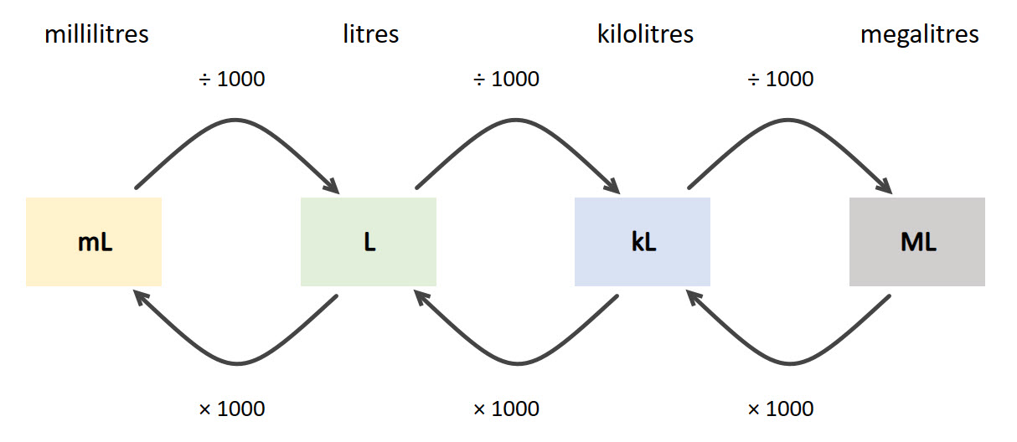Converting from one unit of measurement to another

| **Steps** | **Thinking** | **Calculation** |
| --- | --- | --- |
| 1. Locate the units of measurement you have on the diagram. | Diagram shows that you multiply by 1000 to get from millilitres to litres. | I have 3.265 litres. |
| 1. Locate the units of measurement you want to convert to on the diagram. | Diagram shows that you divide by 1000 to get from litres to millilitres. | I want to convert to millilitres. |
| 1. Which of the two arrows goes in the direction you are converting to? | Diagram shows what you need to do to convert from litres to millilitres (and reverse) | The arrow is going from litres to millilitres (× 1000). |
| 1. Anticipate the answer. | Going from a larger unit of measurement to a smaller one | The number will be larger. |
| 1. Calculate the answer. | The digits will move 3 places to the left | 3.265 × 1000 = 3265 mL |
| 1. Check your answer, does it make sense? | 1 L is equivalent to 1000 mL | The answer makes sense. |