Osprey position and location
Year level  Strand(s)  Lesson length  CD Code: | - Year 5, Year 6  - Statistics / Space  - 60 mins  - AC9M5ST01  - AC9M6ST01  - AC9M5SP02  - AC9M6SP02
Lesson summary | In this lesson, students acquire data related to the migration of the osprey. Students describe location and position on a Cartesian plane using paired coordinates. They explore the way latitude and longitude is used to pinpoint a location on Earth.  This lesson is the fourth in a series of six lessons that connect the cross-curriculum priority of Sustainability, Statistics and the Science learning area: Science as a human endeavour. AC9S5H01, AC9S6H01 and AC9S5H02, AC9S6H02.  This lesson was developed in collaboration with Conservation Without Borders. Data and information provided by Tweed Valley Osprey Project.
Learning intention | - We are learning about ways to represent and report on real scientific data.  - We will use the research tasks to develop our understanding of location and position.
Success criteria | By the end of this lesson, students can:  - describe location and position on a Cartesian plane using paired coordinates  - describe the way latitude and longitude are used to pinpoint a location on Earth  - plot points on a grid using simplified latitude and longitude reference points  - interpret location data plotted on a map to identify a mystery bird.
Why are we learning about this? | The work done by research teams helps us to learn more about the natural world. Using the context of contributing to a research team gathering data, we can identify patterns, analyse trends, and observe changes over time. Exploring basic technologies, such as GPS tracking used by scientists, enhances our understanding of data collection and analysis. Additionally, mastering the creation and interpretation of data displays is a crucial skill, as it allows us to communicate information effectively through visual means.
Prerequisite student knowledge and language | Prior to this lesson, it is assumed that students have knowledge of:  - the Cartesian plane to locate position  - interpreting a simple map of the world  - interpreting information in a table  - representing data in column graphs  - different ways to visualise data other than a column graph.  It is also assumed students are familiar with terms such as:  - position and location  - global positioning system (GPS)  - migration.
Resources | Resources  - Lesson plan (Word)  - Teacher’s slides (PowerPoint)  - Locating points on a Cartesian plane (Word)  - Mystery birds sheet (Word)  - Sacha Dench profile poster  - Optional: teacher access to computer/tablet; Location and position data (Excel); spreadsheet software such as Excel (MS); an online mapping tool such as Google My Maps
Curriculum information
Achievement standard | By the end of Year 5, students use grid coordinates to locate and move positions. They interpret and compare data sets for ordinal and nominal categorical, discrete and continuous numerical variables using comparative displays or visualisations and digital tools. They identify the mode and interpret the shape of distributions of data in context. They compare distributions of discrete and continuous numerical and ordinal categorical data sets as part of their statistical investigations, using digital tools.  By the end of Year 6, students locate an ordered pair in any one of the four quadrants on the Cartesian plane. They compare distributions of discrete and continuous numerical and ordinal categorical data sets as part of their statistical investigations, using digital tools.
Content description(s) | Students acquire, validate and represent data for nominal and ordinal categorical and discrete numerical variables, to address a question of interest or purpose using software including spreadsheets; discuss and report on data distributions in terms of highest frequency (mode) and shape, in the context of the data. AC9M5ST01  Students interpret and compare data sets for ordinal and nominal categorical, discrete and continuous numerical variables using comparative displays or visualisations and digital tools; compare distributions in terms of mode, range and shape. AC9M6ST01  Students construct a grid coordinate system that uses coordinates to locate positions within a space; use coordinates and directional language to describe position and movement. AC9M5SP02  Students locate points in the four quadrants of a Cartesian plane; describe changes to the coordinates when a point is moved to a different position in the plane. AC9M6SP02
General capabilities  Cross-curriculum priority | General capabilities  Numeracy  - Interpreting and representing data (Level 4)  - Positioning and locating (Level 5)  Digital literacy  - Investigating: Interpret data (Level 4)  Cross-curriculum priorities  Sustainability  - Futures (SF1)
Areas of challenge | Some students may:  - be unfamiliar with directional language to describe location and position  - inaccurately plot points on a Cartesian plane and not follow convention of x being the first value and y the second value in the pair of coordinates, for example, (3, 5)  - have difficulty transferring data in a table to a visual representation such as a map.
Strategies | - Mathematics investigation  - Questioning  - Explicit teaching
Lesson structure
Learning hook  5 mins | - Pose the question, ‘How would scientists discover where birds such as the osprey migrate?’  - Through initial discussion students may mention tracking birds using GPS, scientific observations, community sightings or some form of tagging such as banding.  - Explain that today you will be looking at data that helps scientists determine the position and location of osprey.
Explore  50 mins | Introduction (15mins)  - Explain that one way to describe the location of an object is to use paired coordinates (x) and (y) such as on a Cartesian plane. Make explicit that the x coordinate in the pair is always first, y is next.  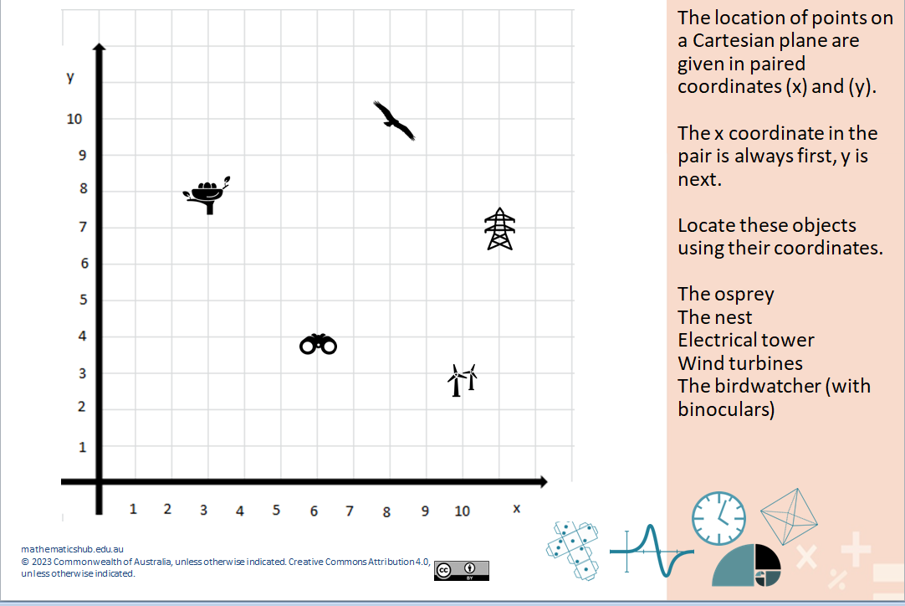  Slide 3  - Use slides 3 and 4 to introduce the Cartesian plane. Depending on your student’s familiarity with the concept of plotting coordinates on a Cartesian plane, you may decide to run this section as a class activity. For students familiar with the Cartesian plane, provide them with the Locating points on a Cartesian plane sheet.  Explicit teaching (10mins)  - Learn more about latitude and longitude. Use questioning and feedback as required to assist students to understand that latitude and longitude together pinpoint an object on Earth.  Note, for students at this level we have simplified latitude and longitude numbers in our table to whole numbers (slide 5). More accurate measures are used in data collected by GPS tracking and would typically include date, time and accurate latitude and longitude reference points. For example: 8/07/2022 at a time of 23:45:00 the osprey Glen was at a latitude of 55.242561 and longitude -3.399452 In our data we have used north (N) for latitude and west (W) for longitude to indicate the global position.  - Mouse click to reveal an animation (highlighted latitude and longitude columns of data).  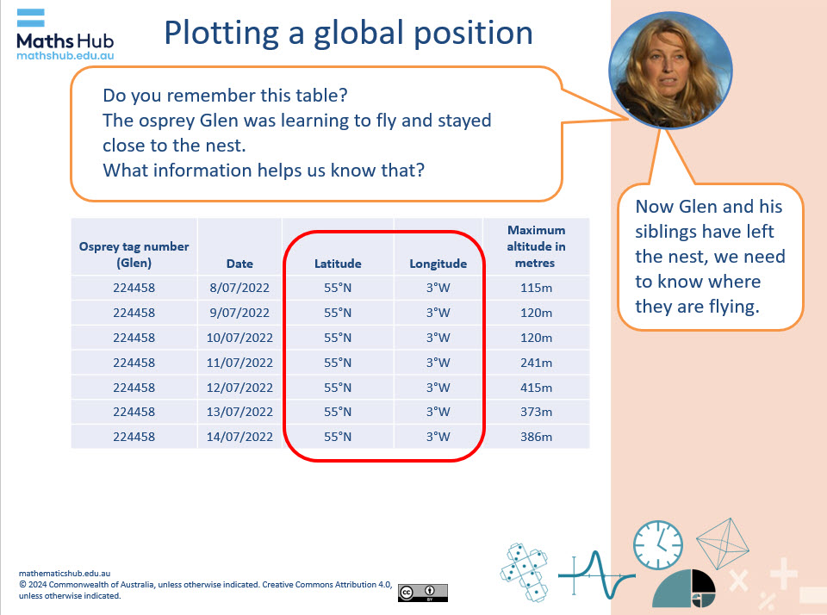  Slide 5  - Use slide 6 to explain global position and location in simple terms:  - Latitude is east and west (sideways).  - Longitude is north and south (up and down).  - The equator is the imaginary line that divides the northern and southern hemispheres.  - North is above the equator and south is below the equator.  - Introduce the use of GPS technology to track the osprey (slide 7).  Practical activity (20 min)  - Introduce the task of plotting paired latitude and longitude reference points from real migration data (slides 8 and 9).  - Distribute the Mystery birds sheet, which contains a table of data and related mapping grid for students plot the pathway of a mystery bird.  - The Location and position data Excel spreadsheet can be used by teachers to demonstrate how latitude and longitude data can be automatically plotted on online mapping software such as Google: My Maps.  Differentiation (support)  - Plot a reduced number of points. Where did your mystery bird start flying? Where did it finish?  Differentiation (enable)  - Where did your mystery bird fly on its migration pathway? How can you represent that on a map?  Differentiation (extend)  - Without plotting the points, what can you predict from the data in the table? How can you work out if you were correct?
Summary and reflection  10 mins | Display slide 11 to summarise the activity and identify the mystery birds.  - Ask students which colour pathway matched their mystery bird. The birds are given names. The birds that corresponded to the data were:  - Glen (ended in Western Sahara, Africa)  - Kirk (ended in Ireland)  - Tweed (ended in Portugal).  - Ask students to use their map showing the pathway and their plotted pathway to identify the mystery bird they chose.
Assessment | Students answer the question: ‘How do scientists discover where birds such as the osprey migrate?’ They use their maps as evidence and describe how two points can be used for global positioning.  Ask students how mapping on a Cartesian plane and mapping using latitude and longitude reference points are similar and different.  Some suggestions may include:  - Both use coordinates: Cartesian plane uses (x, y) coordinates the other uses (latitude, longitude) coordinates.  - Both feature direction: on a Cartesian plane positive x-direction to the right, positive y-direction upwards and with latitude and longitude, latitude increases northwards, longitude increases eastwards.  - Position can be plotted: on a Cartesian plane points are plotted as (x, y); on a grid with latitude and longitude, points are represented as (latitude, longitude) on a map.  Assessment support:  - For Year 5 students assess their proficiency in using grid coordinates to locate and move positions. Refer to their accuracy in plotting and describing points on the Cartesian plane. Discuss their map representing the pathway of their mystery bird. Are the points plotted accurately? Can they explain how they plotted the points using the reference points in the table?  - Year 6 students should be able to locate an ordered pair in any one of the 4 quadrants on the Cartesian plane. Note in this activity we used only the first quadrant. Discuss with students their plotting on the Cartesian plane and use of latitude and longitude.

