Activity 1: Exploring the network answers

1. The capital cities
2. Distance
3. Brisbane (4)
4. Hobart (1)
5. 2,846 km
6. Perth and Adelaide
7. See distances added to diagram below.

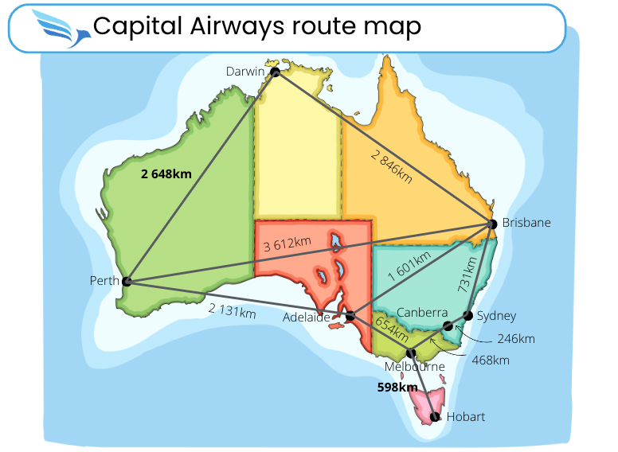

Image: Map of Australia care of KVASVECTOR via Canva.com

1. Perth and Brisbane: 3,612 km
2. 598 + 654 = 1,252 km
3. Direct: 1,601 km. Via Melbourne: 654 + 468 + 246 + 731 = 2,099 km taking four flights

Difference = 2,099 – 1,601 = 498 km.

A network diagram map showing air routes between Australian capital cities. Distances on each edge of the diagrams are also labelled.
A to B (Adelaide to Brisbane)=1601km
B to S (Brisbane to Sydney)=731 km
S to C (Sydney to Canberra)=246 km
C to M (Canberra to Melbourne)=468 km
A to P (Adelaide to Perth)=2131km
P to D (Perth to Darwin)=2846km
D to B (Darwin to Brisbane)=2846km
P to B (Perth to Brisbane)=161km
M to H (Melbourne to Hobart)=598km

1. One example route is: Hobart – Melbourne – Canberra – Sydney – Brisbane – Darwin – Perth - Adelaide

Total distance = 598 + 468 + 246 + 731 + 2846 + 2648 + 2131 = 7020km

To avoid retracing your steps, Hobart must either be the end or start point as there is only one edge connected to Hobart i.e. only one route in and out.

1. No. For a continuous route to be possible using all edges (known as a Eulerian walk), all vertices must either have even degree (where degree is the number of edges connected to a vertex) or there must be exactly two vertices with odd degree (the start and finish point – see Bridges of Königsberg problem).
2. As Perth, Melbourne, Adelaide and Hobart all have odd degree such a route is not possible.