Flags of Asia (worksheet 1)

Afghanistan  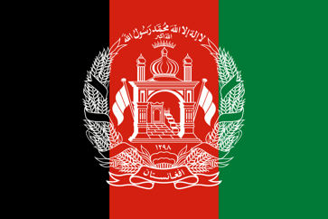 | Armenia  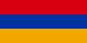 | Azerbaijan | Bahrain
Bangladesh  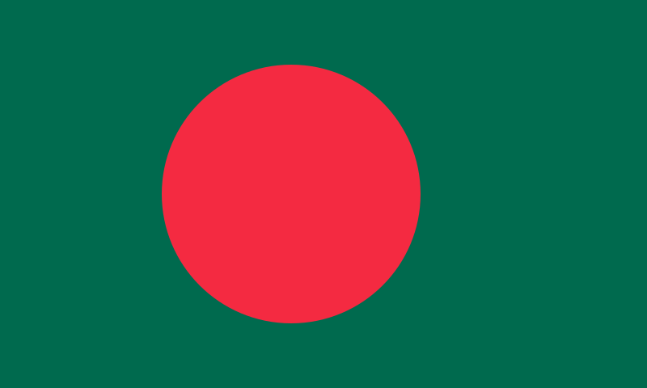 | Bhutan | Brunei | Cambodia  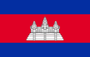
China | Cyprus | Georgia | India  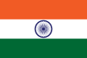
Indonesia | Iran  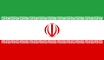 | Iraq  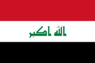 | Israel  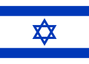
Japan | Jordan  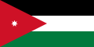 | Kazakhstan | Kuwait  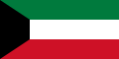
Kyrgyzstan  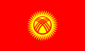 | Laos  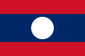 | Lebanon  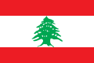 | Malaysia  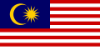

My flag
I have chosen the flag from _______________________________.

My partner’s flag

My partner has chosen the flag from _______________________________.
Flags of Asia (worksheet 2)

Maldives  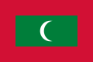 | Mongolia | Myanmar  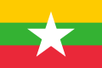 | Nepal  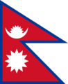
North Korea | Oman | Pakistan | Philippines
Qatar | Saudi Arabia | Singapore | South Korea
Sri Lanka | State of Palestine  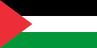 | Syria  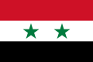 | Tajikistan  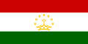
Thailand  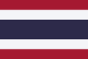 | Timor-Leste | Turkey | Turkmenistan  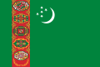
United Arab Emirates  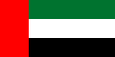 | Uzbekistan  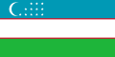 | Vietnam | Yemen

My flag
I have chosen the flag from _______________________________.

My partner’s flag

My partner has chosen the flag from _______________________________.

