Name:

Class:

Geometric assessment

Instructions

If you know the size of the angles **a** and **b**, how many **other** angles can you determine?

Use geometric reasoning with terminology to explain how you can determine each angle. There are templates of these shapes as well as space on the next page to explain your reasoning.

You may wish to use coloured markers or pencils to help communicate your results clearly.

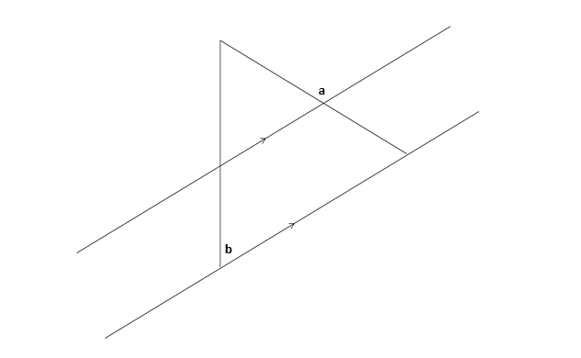

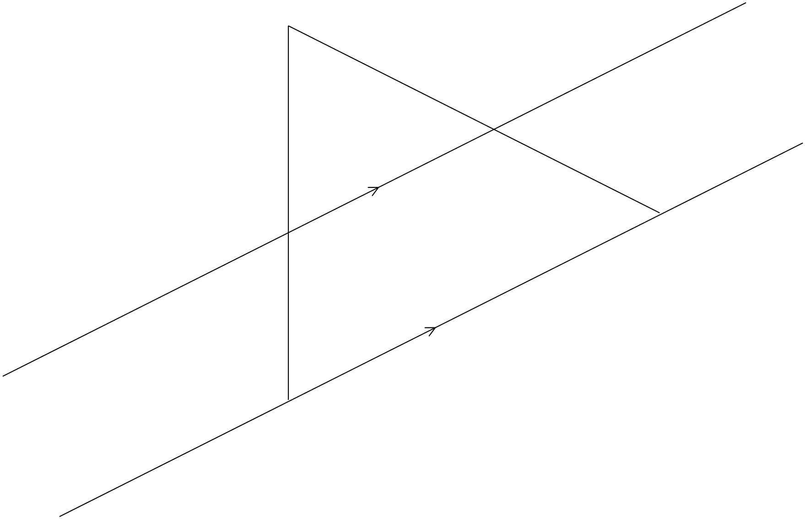



|  |
| --- |
| In summary, my findings are: |
|  |
|  |
|  |
|  |
|  |
|  |