Teacher background

Artificial intelligence (AI) is the ability of machines to mimic human capabilities in a way that we would consider 'smart'.
Machine learning is an application of AI. With machine learning, we give the machine lots of examples of data, demonstrating what we would like it to do so that it can figure out how to achieve a goal on its own. The machine learns and adapts its strategy to achieve the goal.
In our example, we are feeding the machine images of hand gestures via the inbuilt camera. The more varied the data we provide, the more likely the AI will correctly classify the input as the appropriate emotion. In machine learning, the system will give a confidence value; in this case, a percentage and the bar filled or partially filled, represented by colour. The confidence value provides us with an indication of how sure the AI is of its classification.
This lesson focuses on the concept of classification. Classification is a learning technique used to group data based on attributes or features.
The pre-made AI models were created using different data sets.
- Limited data set :Rock, paper, scissors model 1
- More extensive data set: Rock, paper, scissors model 2
As part of a Digital Technologies focused lesson students could create and test their own AI model that recognises hand gestures using Teachable Machine.
Using one of the models as an example, talk about the bar on the Teachable Machine interface, which displays the AI’s confidence level.

Correct: 100% sure | Correct: reasonably sure | Incorrect
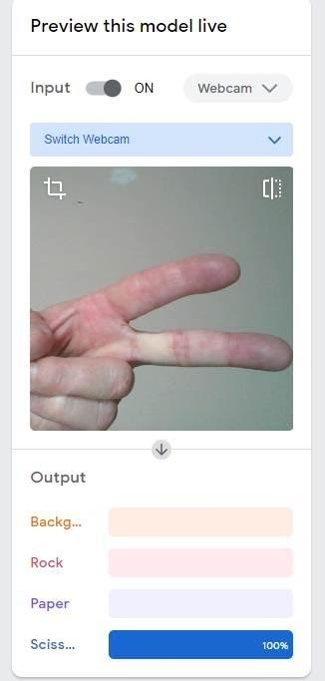 | 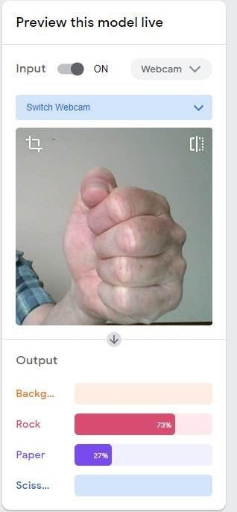 | 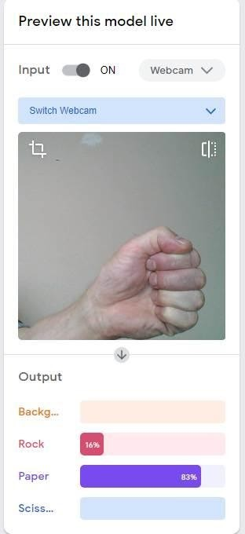
The model is working as expected. The scissors are predicted with 100% confidence. | The model is working as expected. The rock is predicted with 73% confidence. | The model is not working as expected. The model predicts the hand gesture is paper (83%) and less sure it’s a rock (16%). Sufficient data may not have been used in training.
At the conclusion of the lesson, discuss this statement:
- A bias may be experienced if the data used does not contain a diverse range. Examples may include one size or one type of image.

