Is this claim true?

A pizza company has advertised a new extra-large size pizza. It is 46 cm in diameter and costs $27.

The company claims the new size gives customers 50% more pizza.

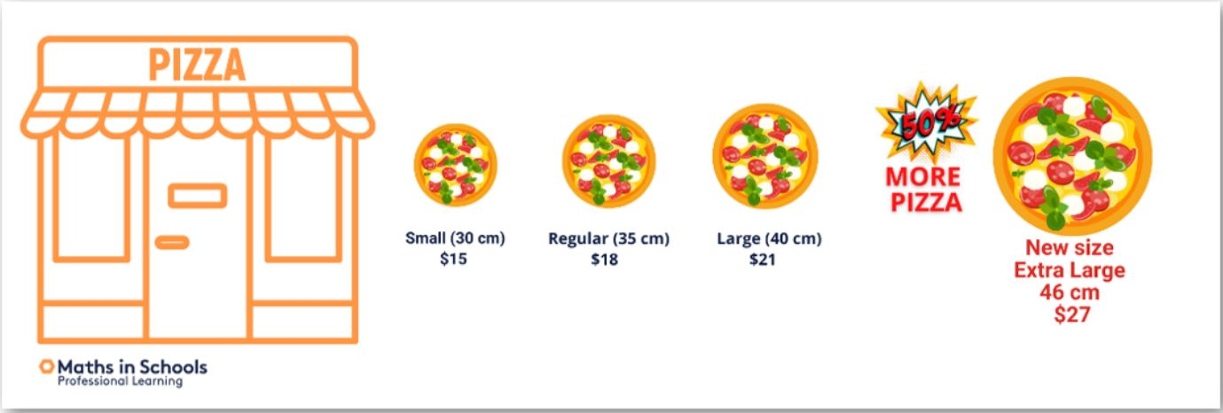

**Use the 4-STEP PROBLEM-SOLVING MODEL**

Identify and describe

List the key information:

1. ___________________
2. ___________________
3. ___________________
4. ___________________
5. ___________________

Plan

Describe the approach you are going to use. Consider how you’ll start and the steps you’ll take to analyse the size claim. Think about different strategies, such as using formulas, physical materials or digital tools that might help.

|  |
| --- |
|  |

Apply and do

You may use area formulas for each pizza and compare the areas, expressing them as percentages.

You may prefer to use physical materials such as grid paper and pizza cut outs for each pizza with different diameters. Then you would count the grid squares and compare.

If you’re familiar with Excel, Numbers or Google Sheets, use a spreadsheet to create formulas to automate the process.

Another way would be to express one pizza as a ratio to another.

Communicate

Communicate your ideas and represent your mathematical thinking.

* What do you need to include in your representation?
* What visuals will you use?​
* What information is important?​
* How might labelling be useful?
* Do you agree with the company’s claim?

|  |
| --- |
|  |

Explain why you chose your method of modelling the problem.

Create a new ad with your own claim about the increase in size difference between two pizzas, for example, between the large and extra-large pizzas.