Activity 2

Improving the network

Capital Airways is in serious trouble and is suffering big losses. As the new CEO you brief the executive team with what you believe is the way forward. Your idea is to build a detailed mathematical model to calculate the profit flying different routes to try and optimise the route map and return Capital to profitability.

Brief to return to profit

* Build a mathematical model to calculate the profit flying different routes.
* Find optimal route/s and restructure the route map.
* Present findings to the Capital Airways Board.

Assumptions and task

Assume Capital Airways can fly any 10 routes in the network (i.e. connecting any pair of capitals), but the final route map must allow travel between **all** capitals.

There are 10 planes in the Capital fleet:

* 5 Boeing 737-Max 7 planes (140 passengers)
* 5 Airbus 321 Neos (220 passengers).

1. Use the information on the following page (also in Excel spreadsheet) providing passenger numbers and city populations to determine routes and which plane will fly each route.
2. Build a mathematical model calculating the total daily profit from your route network.
3. Create two revised network maps (on the maps provided) showing:

* chosen routes
* projected daily passenger numbers on each route
* projected daily profit on each route.

1. Summarise the key points of the route map in 5 bullet points to be presented to the Capital Airways Board.

Helpful notes

* Decide your routes and note the current passenger numbers on each route. For each route you must choose the plane you will use, how full you estimate the route will be (% capacity) and ticket price.
* Remember that as you increase price, capacity will fall. You will need to consider ticket prices charged by competitors as well as demand on the route (current passenger numbers).
* Calculate fuel cost, by finding the route distance and entering it into the model, which will then automatically calculate the daily fuel cost.
* Calculate the ground staff and airport fees, which are calculated per passenger but vary for larger versus smaller airports.
* As you vary inputs (blue cells) to the model, the revenue, costs and profit will update, allowing you to test different assumptions.

Additional information

Distances between Australian capitals (km)

|  |  |  |  |  |  |  |  |  |
| --- | --- | --- | --- | --- | --- | --- | --- | --- |
|  | **Sydney** | **Melbourne** | **Brisbane** | **Perth** | **Canberra** | **Darwin** | **Adelaide** | **Hobart** |
| **Sydney** |  | 714 | 731 | 3,297 | 246 | 3,144 | 1,163 | 1,059 |
| **Melbourne** | 714 |  | 1,374 | 2,728 | 468 | 3,142 | 654 | 598 |
| **Brisbane** | 731 | 1,374 |  | 3,612 | 942 | 2,846 | 1,601 | 1,789 |
| **Perth** | 3,297 | 2,728 | 3,612 |  | 3,095 | 2,648 | 2,131 | 3,010 |
| **Canberra** | 246 | 468 | 942 | 3,095 |  | 3,127 | 947 | 833 |
| **Darwin** | 3,144 | 3,142 | 2,846 | 2,648 | 3,127 |  | 2,618 | 3,736 |
| **Adelaide** | 1,163 | 654 | 1,601 | 2,131 | 947 | 2,618 |  | 1,162 |
| **Hobart** | 1,059 | 598 | 1,789 | 3,010 | 833 | 3,736 | 1,162 |  |

Data: collated from various online geo-mapping sites.

Population of Australian capitals

|  |  |  |  |  |  |  |  |
| --- | --- | --- | --- | --- | --- | --- | --- |
| **Sydney** | 5,259,764 | **Canberra** | 453,558 | **Brisbane** | 2,568,927 | **Adelaide** | 1,402,393 |
| **Melbourne** | 4,976,157 | **Darwin** | 148,801 | **Perth** | 2,192,229 | **Hobart** | 251,047 |

Data: collated ABS: © Commonwealth of Australia

Passenger numbers on major Australian routes (April 2023)

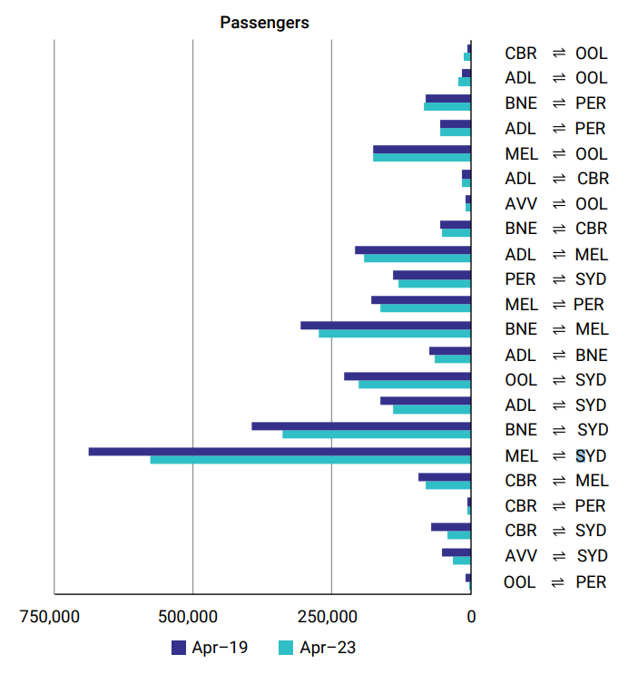

Graph source: June 2023 ACCC Airline competition in Australia report; p.15: © Commonwealth of Australia 2023; Creative Commons Attribution 4.0 Australia licence