Visualising data for a game of Kolap: Part 2
Year level  Strand(s)  Lesson length  CD Code | - Year 1  - Number, Statistics  - 60 mins  - AC9M1N03  - AC9M1N04  - AC9M1ST02
Lesson summary | In this second of two lessons, students create a visual representation of the data collected and recorded while playing a First Nations Australian children’s instructive game of throwing skill called Kolap.  In the first lesson, students collected and recorded the data used in this lesson.  This lesson was developed in collaboration with Caty Morris and Aboriginal and Torres Strait Islander Mathematics Alliance (ATSIMA).
Learning intention | - We are exploring a First Nations Australian instructive game and using our counting skills to keep track of points scored for each successful throw.
Success criteria | By the end of this lesson, students can:  - collect and record data  - use additive strategies to count collections  - interpret a table of data  - visualise and discuss the data using frequencies.
Why are we learning about this? | Students are provided with the opportunity to engage in a real-life mathematics experience that connects mathematics with culture and health and physical education.
Prerequisite student knowledge and language | Prior to this lesson, it is assumed that students have knowledge of:  - use of tally marks  - one-to-one correspondence when using counting processes  - interpreting data in a table.  Terminology and language  A picture graph is data represented as pictures to show how many are in each category. Usually, categories are displayed along an axis. Often the category and frequency are displayed along the axis in line with the pictures for that category.  Frequency in graphing refers to how often something happens or how many times it occurs.
Resources | - Lesson plan (Word)  - Copies of student data tables completed in lesson one: Recording data in a game of Kolap
Curriculum information
Achievement standard | By the end of Year 1, students solve problems involving addition and subtraction of numbers to 20 and use mathematical modelling to solve practical problems involving addition, subtraction, equal sharing and grouping, using calculation strategies. They collect and record categorical data, create one-to-one displays, and compare and discuss the data using frequencies.
Content description(s) | Students quantify sets of objects, to at least 120, by partitioning collections into equal groups using number knowledge and skip counting. AC9M1N03  Students add and subtract numbers within 20, using physical and virtual materials, part-part-whole knowledge to 10 and a variety of calculation strategies. AC9M1N04  Students represent collected data for a categorical variable using one-to-one displays and digital tools where appropriate; compare the data using frequencies and discuss the findings. AC9M1ST02  Note an elaboration for this content description relates directly to this lesson: exploring First Nations Australian children’s instructive games; for example, Kolap from Mer Island in the Torres Strait region, recording the outcomes, representing and discussing the results.
General capabilities  Cross-curriculum priority | General capabilities  Numeracy  - Number sense and algebra Level 3  - Additive strategies Level 6  - Interpreting and representing data Level 2  Cross-curriculum priority  Aboriginal and Torres Strait Islander Histories and Cultures  Culture  - First Nations Australian societies are diverse and have distinct cultural expressions such as language, customs and beliefs. As First Nations Peoples of Australia, they have the right to maintain, control, protect and develop their cultural expressions, while also maintaining the right to control, protect and develop culture as Indigenous Cultural and Intellectual Property. A_TSIC1  People  - Australia has 2 distinct First Nations Peoples; each encompasses a diversity of nations across Australia. Aboriginal Peoples are the first peoples of Australia and have occupied the Australian continent for more than 60,000 years. Torres Strait Islander Peoples are the First Nations Peoples of the Torres Strait and have occupied the region for over 4,000 years. A_TSIP1
Areas of challenge | Some students may:  - be unfamiliar with tallying and inaccurately record a tally not understanding that the fifth tally mark crosses the preceding four tally marks to make a group of 5  - not be familiar with the use of a picture graph to visualise data  - not take into consideration the key that is associated with the picture graph  - incorrectly count the frequency of a category  - have difficulty coming up a with a relevant conclusion from their interpretation of the picture graph.
Strategies | - Culturally responsive pedagogies  - Concrete, Representational, Abstract (CRA model)  - Explicit teaching  - Collaborative learning  - Differentiation
Lesson structure
Learning hook  5 mins | - Refer to the data recording sheets created in the previous lesson.  - Explain that we can visualise that data and create a picture graph. We can use the picture graph to look for patterns and make conclusions about playing the game.
Explore  45 mins | - Display each team’s data so you can view it as a class.  Picture graph of team data  - Use an example of a team’s data table to discuss what pictures may be used to represent the data.  - For example, in this case of the example data recording table, each player’s throws were made using bean bags as the kolap. Each successful throw can be represented as a picture of a bean bag. Explain that the name of the category is the player’s name and the frequency is the number of successful throws represented as the tally marks.  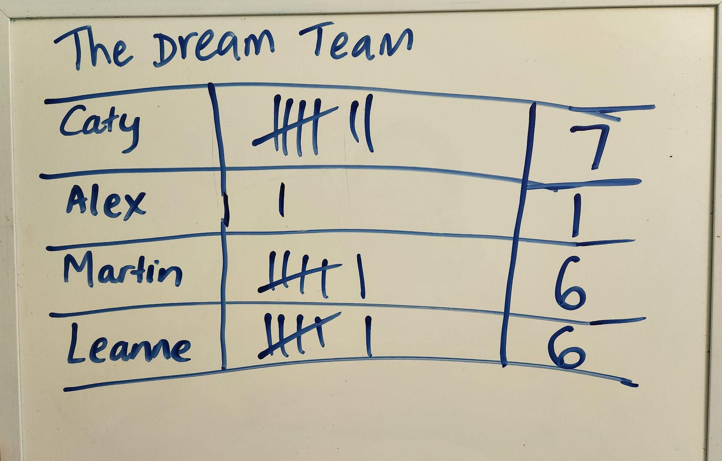  Example data recording table  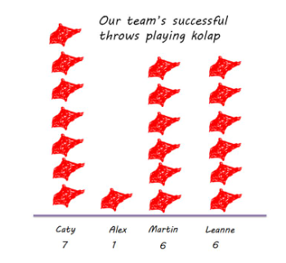  Example picture graph  Picture graph of class data  - Some students may want to create a picture graph of the class data. This may show how the teams compared.  - Explain that in that case, the category would be the team instead of the individual player and the frequency would be the team total.  Collaborative learning  - Provide materials to students to create their picture graphs. You may decide that this is an individual or paired activity depending on your students’ familiarity with creating a picture graph. For those unfamiliar with working collaboratively, having a partner often supports their learning.  Differentiation  - Enabling prompts: What did your team’s score show?  - Extending prompt: How did your team’s score compare to other teams?
Summary and reflection  10 mins | - Display the completed picture graphs.  - Asks students what conclusions they can draw from the picture graphs.  - Use terminology such as categories and frequency in context.
Assessment | - Does the picture graph include relevant labels for each category and frequency which is accurate?  - Can the student draw relevant conclusions from theirs and others picture graphs?

