Worksheet 1: Measurement accuracy and rounding

WORKED EXAMPLE

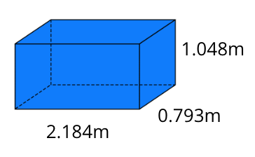

Question 1

1. For the rectangular prism, find the volume using the measurements shown in the diagram.
$$V=lwh$$

$$V=2.184×0.793×1.048$$

$$V=1.81504378m^{3}$$

2. For the rectangular prism, find the volume rounding the measurements to two decimal places.
$$V=lwh$$

$$V=2.184×0.793×1.048$$

$$V=1.80831m^{3}$$

3. Calculate the error in parts **a.** and **b.** (difference between the volume).

Error = $1.81504378-1.80831{=0.0067m}^{3}$

1. Express your answer to part **b.** as a percentage of the original volume found using the most accurate measurements.

% error = $\frac{0.0067}{1.81504378}×100=0.37\%$

Question 2

Repeat steps **b.**, **c. and** **d.** from **Question 1** using the original measurements rounded to one decimal place. Compare your answers.

$V=2.2×0.8×1.0$

$$V=1.76m^{3}$$

2. Error = $1.81504378-1.76{=0.0550m}^{3}$
3. % error $=\frac{0.0550}{1.81504378}×100=3.03\%$

Question 3

Repeat steps **b.**, **c. and** **d.** from **Question 1** using the original measurements rounded to the nearest whole number. Compare your answers once again.

$V=2×1×1$

$$V=2m^{3}$$

1. Error = $1.81504378-2$ ${=-0.1850m}^{3}$

Differences are always expressed as a positive number ${=0.1850m}^{3}$.

1. % error $=\frac{0.1850}{1.81504378}×100=10.19\%$

YOU TRY

Repeat the same process as in the worked example to answer the following question:

Will we get the biggest error when we round to two decimal places, one decimal place or to the nearest whole number?

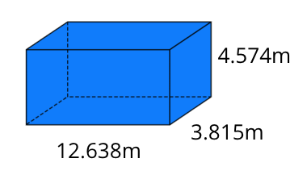

1. **a.** Find the volume of the prism using the given measurements on the diagram.

**b.** Find the volume of the prism rounding the measurements to two decimal places.

**c.** Calculate the error in parts **1.a.** and **1.b.** (difference between the volume).

**d.** Express your answer to **1.c.** as a percentage of the original volume found using the most accurate measurements.

1. Repeat parts **1.b.–d.** using the original measurements rounded to one decimal place.
2. Repeat parts **1.b.–d.** using the original measurements rounded to the nearest whole number.
3. Compare the three volumes resulting from questions **1**, **2** and **3**. Which method of rounding gives the biggest percentage error? Why? Will this always be the case?

YOU TRY – SOLUTIONS



1. **a. $V=lwh$**

$$V=12.638×3.815×4.574$$

$$V=220.530699m^{3}$$

$V=12.64×3.82×4.57$

All the numbers are rounded to two decimal places e.g. $12.638≈12.64$



$$V=220.661536m^{3}$$

$220.661536-220.530699$ ${=0.1308m}^{3}$

$\frac{0.1308}{220.530699}×100=0.06\%$

Take the difference and divide by the original volume. Multiply by 100 to turn this into the percentage error.

$V=12.6×3.8×4.6$

$$V=220.248m^{3}$$

Error = $220.530699-220.248m^{3}$ = $0.282699$

The two calculations of volume are subtracted to find the error in $m^{3}$. Always subtract the smaller number from the bigger so the answer is positive.

% error = $\frac{0.282699}{220.530699}×100=$**0.13%** (2 decimal places)

$V=13×4×5$

$$V=2{60m}^{3}$$

Error $=260-220.530699$ $=39.469301$

% error = $\frac{39.469301}{220.530699}×100= 7.9\%$

1. Rounding to the nearest whole number because the numbers change significantly, for example, $4.574≈5$. You would expect this as the more you round a number the less accurate it becomes.