What number is represented by each decimat?

This number is _______ This number is _______ This number is _______

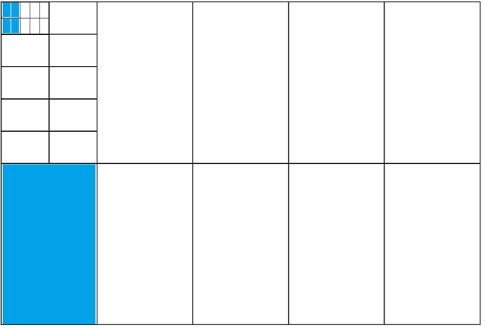 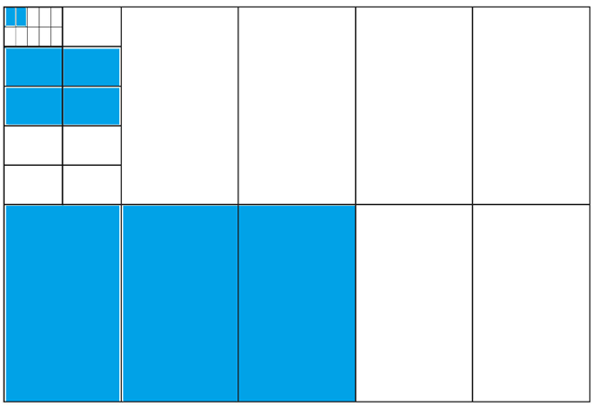 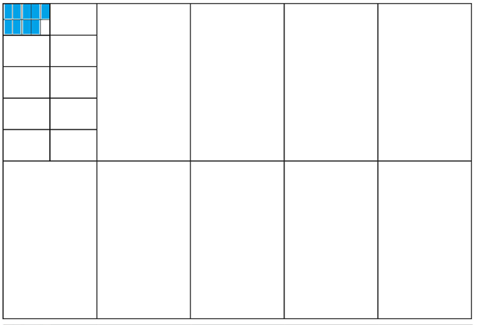

This number is _______ This number is _______ This number is _______

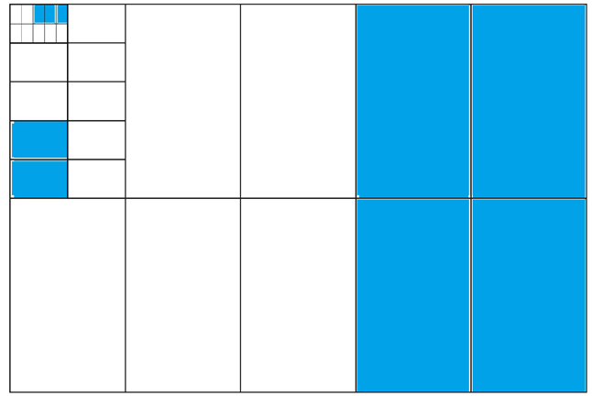 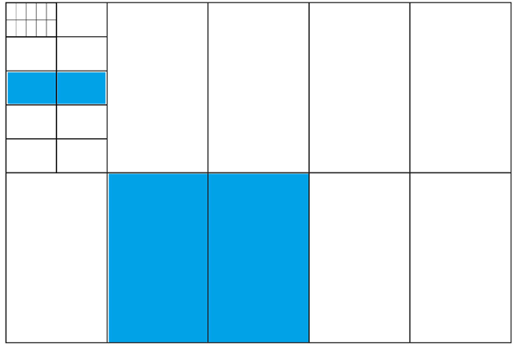 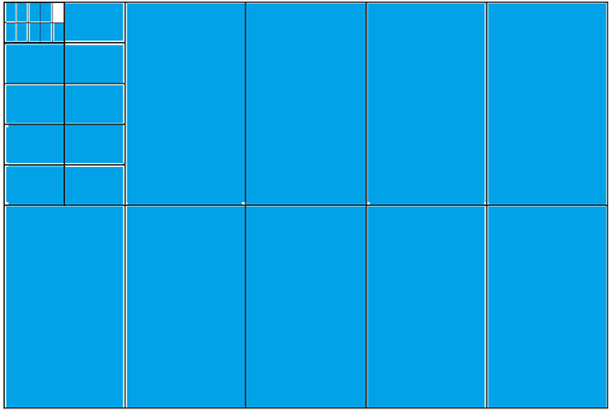

Choose a decimal number to represent using a decimat.

My number _______ My number _______

