Recording data in a game of Kolap: Part 1
Year level  Strand(s)  Lesson length  CD Code | - Year 1  - Number, Statistics  - 60 mins  - AC9M1N03  - AC9M1N04  - AC9M1ST02
Lesson summary | In this first of two lessons, students investigate and play a First Nations Australian children’s instructive game of throwing skill called Kolap. They collect and represent data, and discuss their findings.  In the second lesson, students create a visual representation of the data collected and recorded in this lesson.  This lesson was developed in collaboration with Caty Morris and Aboriginal and Torres Strait Islander Mathematics Alliance (ATSIMA).
Learning intention | - We are exploring a First Nations Australian instructive game and using our counting skills to keep track of points scored for each successful throw.
Success criteria | By the end of this lesson, students can:  - cooperate with others to play a game  - collect and record data  - use additive strategies to count collections.
Why are we learning about this? | Students are provided with the opportunity to engage in a real-life mathematics experience that connects mathematics with culture and health and physical education.
Prerequisite student knowledge and language | Prior to this lesson, it is assumed that students have knowledge of:  - how to use of tally marks  - one-to-one correspondence when using counting processes.
Resources | - Lesson plan (Word)  - Instructions to play Kolap (PDF)  - Teacher background information sheet (Word)  - Plastic hoops, mats or similar for a target and beanbags or such as natural materials such as gum nuts similar for the kolap  - Paper and markers (or chalkboards and chalk; mini-whiteboards and markers) for tallying/recording results
Curriculum information
Achievement standard | By the end of Year 1, students solve problems involving addition and subtraction of numbers to 20 and use mathematical modelling to solve practical problems involving addition, subtraction, equal sharing and grouping, using calculation strategies. They collect and record categorical data, create one-to-one displays, and compare and discuss the data using frequencies.
Content description(s) | Students quantify sets of objects, to at least 120, by partitioning collections into equal groups using number knowledge and skip counting. AC9M1N03  Students add and subtract numbers within 20, using physical and virtual materials, part-part-whole knowledge to 10 and a variety of calculation strategies. AC9M1N04  Students represent collected data for a categorical variable using one-to-one displays and digital tools where appropriate; compare the data using frequencies and discuss the findings. AC9M1ST02  - Note an elaboration for this content description relates directly to this lesson: exploring First Nations Australian children’s instructive games; for example, Kolap from Mer Island in the Torres Strait region, recording the outcomes, representing and discussing the results.
General capabilities  Cross-curriculum priority | General capabilities  Numeracy  - Number sense and algebra Level 3  - Additive strategies Level 6  - Interpreting and representing data Level 2  Cross-curriculum priority  Aboriginal and Torres Strait Islander Histories and Cultures  Culture  - First Nations Australian societies are diverse and have distinct cultural expressions such as language, customs and beliefs. As First Nations Peoples of Australia, they have the right to maintain, control, protect and develop their cultural expressions, while also maintaining the right to control, protect and develop culture as Indigenous Cultural and Intellectual Property. A_TSIC1  People  - Australia has 2 distinct First Nations Peoples; each encompasses a diversity of nations across Australia. Aboriginal Peoples are the first peoples of Australia and have occupied the Australian continent for more than 60,000 years. Torres Strait Islander Peoples are the First Nations Peoples of the Torres Strait and have occupied the region for over 4,000 years. A_TSIP1
Areas of challenge | Some students may:  - be unfamiliar with tallying and inaccurately record a tally not understanding that the fifth tally mark crosses the preceding four tally marks to make a group of 5  - believe that all throws count and proceed to mark tally marks for all throws, regardless of whether they’re successful; support students to understand the rules of scoring in this particular game and the goal of landing throws within the target area  - still be developing one-to-one correspondence and their tally mark recording may not match the number of successful throws; encourage students to check their tally marks match with the number of kolaps on the mat before clearing the mat, and encourage students to work together to focus on and keep track of the score.
Strategies | - Culturally responsive pedagogies  - Collaborative learning  - Concrete, Representational, Abstract (CRA model)  - Explicit teaching  - Differentiation
Lesson structure
Learning hook  10 mins | - Prior to the lesson, read the teacher background information which contextualises the cultural context for this lesson.  - Introduce the cultural context for the lesson and how it relates to Kolap, the First Nations Australian children’s instructive game using throwing skills.  - Set up a target and model how to record successful and unsuccessful throws. Model how to record successful throws using tally marks. Ensure students are clear on accurately counting and recording the tally marks emphasising the fifth successful throw tally mark crosses the preceding four tally marks to make a group of 5.
Explore  40 mins | - Take the class outside or to a large indoor area such as a gym.  - Mark out the games area with start line and targets. Organise students into 4 equal teams with their ‘kolaps’. Each student gets 4 throws. The team that records 20 successful throws is the winner.  Collaborative learning  - Provide paper and markers (or chalkboards and chalk, or mini-whiteboards and markers) to record tally marks for each team. Model how to record a successful throw using one team as an example as they demonstrate a practice run. Each team designates someone to record the successful throws; the recorder swaps temporarily with another player when it is their turn. Discuss ways to ensure the team tally is recorded accurately.  - Show an example of a way to record the data that uses a table to organise tally marks recorded against each player of the team. When the team score reaches 20, the team signals that they have finished.  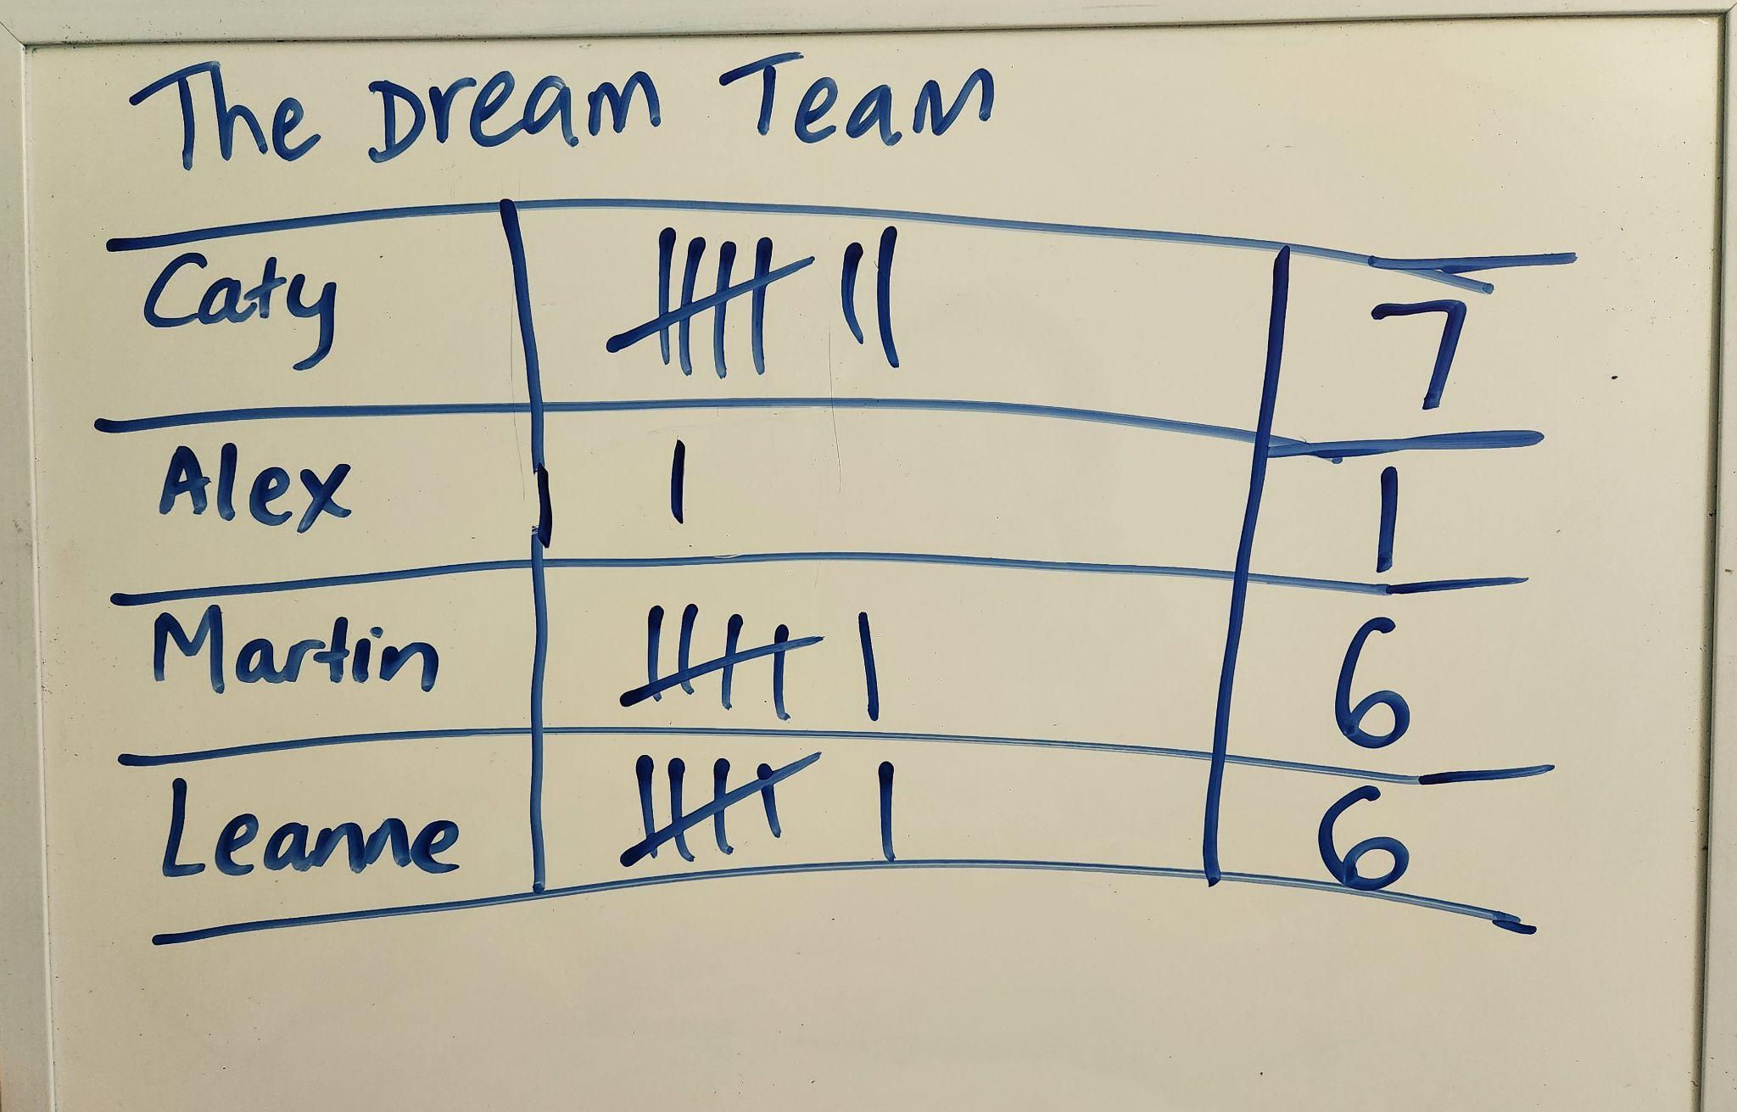  Example data recording table  - Explain that the data recorded will be used for the next maths lesson.  Differentiation  - Enabling prompts: What did each player score? What is the total?  - Extending prompt: How many rounds do you think it will take to reach a team score of 20?
Summary and reflection  10 mins | - Display the completed tables of recorded data.  - Discuss any challenges they experienced in collecting and recording the data. How well did they work collaboratively?  - Interpret the data tables and look for patterns.  - Discuss the approaches used to ensure their data was accurate for example counting as a group, having a person in the team checking the counting and tallying.  - Note: Keep the data recording sheets or make a digital copy to be used in a follow-up lesson to display the data visually, for example, using a pictograph or simple chart.
Assessment | - Use observation and informal conversations to access students’ understanding of ways to collect (tally) and record data.  - What counting process do students use to quantify the team tally? Can students skip count by fives when quantifying the total score?

