Star map

Name:

Class:

Equipment

You will need:

* ruler, compass, pencil, eraser
* Student instruction worksheet

Crux Australis

The five bright stars of the Southern Cross (Crux Australis) are represented on the flags of Australia, Brazil, New Zealand, Papua New Guinea, and Samoa. In 2016, the fifth brightest star was named officially by the International Astronomical Union (IAU) as Ginan, the cultural name used for thousands of years by Aboriginal people. Ginan is seen as a dillybag filled with special songs of knowledge to be passed on.

Constructing a perpendicular bisect

The north and celestial poles are fixed in the sky and are helpful to navigate using the stars. The North Star (Polaris) is located close to the North Celestial Pole, which makes it useful to navigate. However, there is no single bright star near the South Celestial Pole (SCP), so we will use mathematical techniques to find it.

On the star map on the next page, follow the instructions below to locate the Southern Celestial Pole (SCP).

1. Locate the Southern Cross and draw a line from the Gacrux star to the Acrux star, extending the line 4 ½ times beyond its length.
2. Locate the Southern Pointers. Draw a line with your ruler between these two stars.
3. Using your compass draw a perpendicular line that bisects the Southern pointers by constructing two arcs of equal distance from each Southern Pointer star.
4. Join the intersections of these two arcs with a line and extend this until it meets your projection from the Southern Cross.
5. 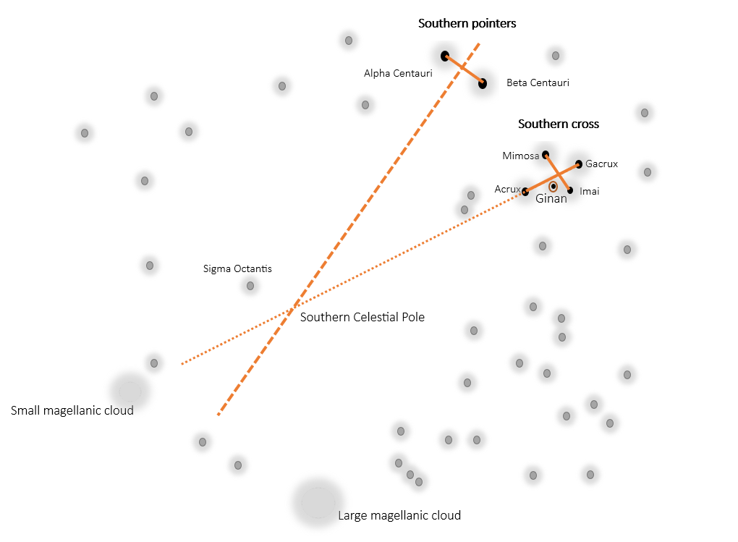The intersection of these lines is a very close estimate to the SCP. Once a navigator has found this point in the night sky, they simply need to move straight down to the ground to find due South. Here is an example below.

Star map

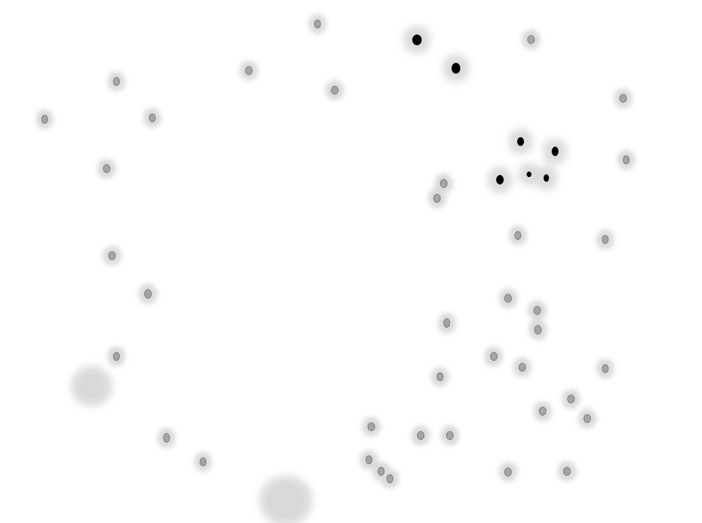

Constructing parallel lines

In this activity, you will construct a set of parallel lines using a compass and ruler. This method works by copying the angle to create an equal corresponding angle at a point. Build your parallel lines in the box on the **next page** by following the instructions below.

1. Draw a straight line with your ruler and pencil on your page. Mark the end points A and B. This is written mathematically as .
2. Draw a point P anywhere in the space above  .
3. Intersecting with P, construct a transversal line with your ruler from A. Your diagram should look something like this.

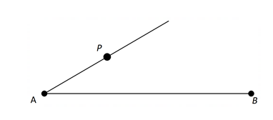

1. Copy the angle BAP to point P by drawing an arc of any length from point A with your compass.
2. Repeat this process from point P without adjusting the width of your compass.

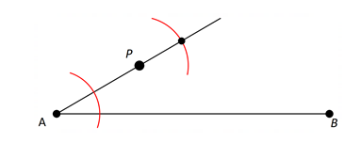

1. Move your compass point to the intersection of the arc drawn from P and the transversal,
2. Draw an arc across the upper arc to form a point C where they intersect.
3. Draw a straight line through points P and C to complete your construction.

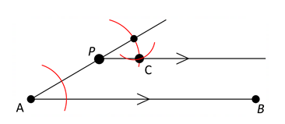

Self-reflection

Am I satisfied with my star map construction? (circle) 

I was successful at:

I can improve on:

My next steps are: