Investigating properties of quadrilaterals

Name
 | Square | Rectangle | Parallelogram | Rhombus | Trapezium | Kite
How many sets of opposites sides are equal?
Are opposite sides in parallel?
Are adjacent sides equal?
How many right angles are there?
Are opposite angles equal?
Are the diagonals equal?
Do diagonals bisect each other?
Do diagonals intersect at right angles?
How many axes of symmetry?

Creating geometric patterns

Textiles or architectural design
- Using inspiration from Asian cultures, on the grid below create a symmetrical design that uses transformations of polygons. You are required to include at least one quadrilateral and one triangle as the major shapes in your design. Once you have completed your design, on the next page:
  - classify the shapes used in your design by their angle and side properties
  - describe the transformations used in your design.

  - Classify the major shapes used in your design by their angle and side properties.
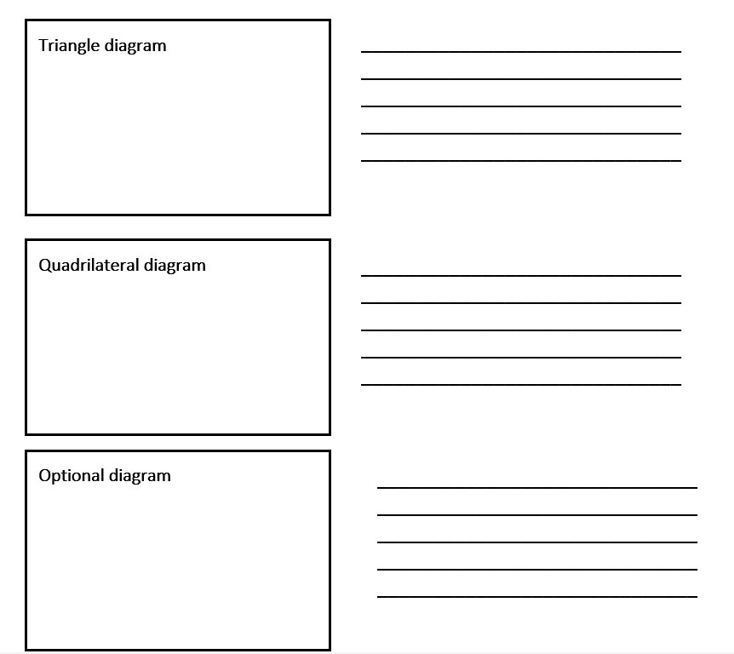
  - Describe the transformations used in your design.
_______________________________________________________________________________________________________________________________________________________________________________________________________________________________________________________________________________________________________

Creating geometric patterns
- Access information on creating circular mandala designs. Using inspiration from Asian cultures, create a symmetrical design that uses transformations of polygons. You are required to include at least one quadrilateral and one triangle as the major shapes in your design. Once you have completed your design, go to the next page to:
  - classify the shapes used in your design by their angle and side properties
  - describe the transformations used in your design.

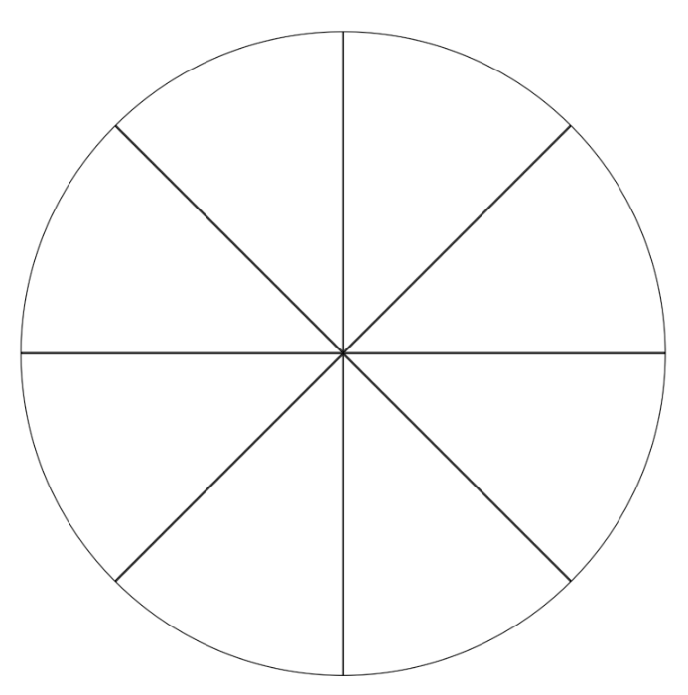

  - Classify the major shapes used in your design by their angle and side properties.
  - Describe the transformations used in your design.
_______________________________________________________________________________________________________________________________________________________________________________________________________________________________________________________________________________________________________

