Fraction shape puzzles
What is the value of each tangram piece?
1. If the combined value of all seven Tangram pieces arranged in a square
is 1, what is the value of each individual piece?
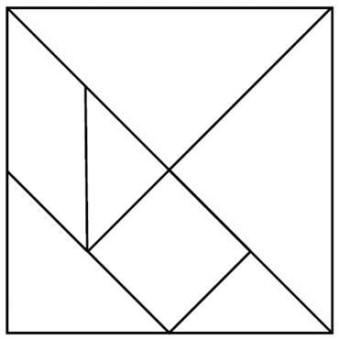
Write your fractions in the boxes below and on the tangram diagram.

a) Each large triangle |  | d) Square
b) Medium triangle |  | e) Parallelogram
c) Each small triangle

Equivalent fractions
2. a) How many small triangles do you need to make a medium triangle?

b) Write a number sentence showing the two equivalent fractions.

3. a) How many small triangles do you need to make a large triangle?

b) Write a number sentence showing the two equivalent fractions.

4. a) How many squares do you need to make the whole tangram?

b) Write a number sentence showing the two equivalent fractions.

Fraction addition
5. a) Create a new shape that is $\frac{1}{2}$ and draw the pieces below (you may need to borrow from and share shapes with a partner).

b) Write a number sentence showing how these different fractions add to $\frac{1}{2}$ .

c) Can you use a different set of pieces to make $\frac{1}{2}$, draw the shape and write a number sentence showing how these pieces add to $\frac{1}{2}$ .

6. a) Create a new shape that is $\frac{3}{4}$ and draw the pieces below.

b) Write a number sentence showing how the different fractions add to $\frac{3}{4}$ .

7. a) Create a new shape that is 1 whole using all the tangram pieces and draw the pieces below.

b) Write a number sentence showing how the different fractions add to 1.

c) You know now that each small triangle is $\frac{1}{16}$. Can you rewrite your number sentence from part b) expressing each shape as a fraction with denominator of 16?

8. Challenge! Can you use some of your tangram pieces, create a shape, remove a piece and write a number sentence that describes the subtraction you have modelled?

